**Module 8 Assignment: Final Project**

Saurabh Verma

Arizona State University

IFT 598: Middleware Programming & Database Security

Professor. Dinesh Sthapit

December 03, 2022

**Project Code Screenshots:**

**Package.json file:**

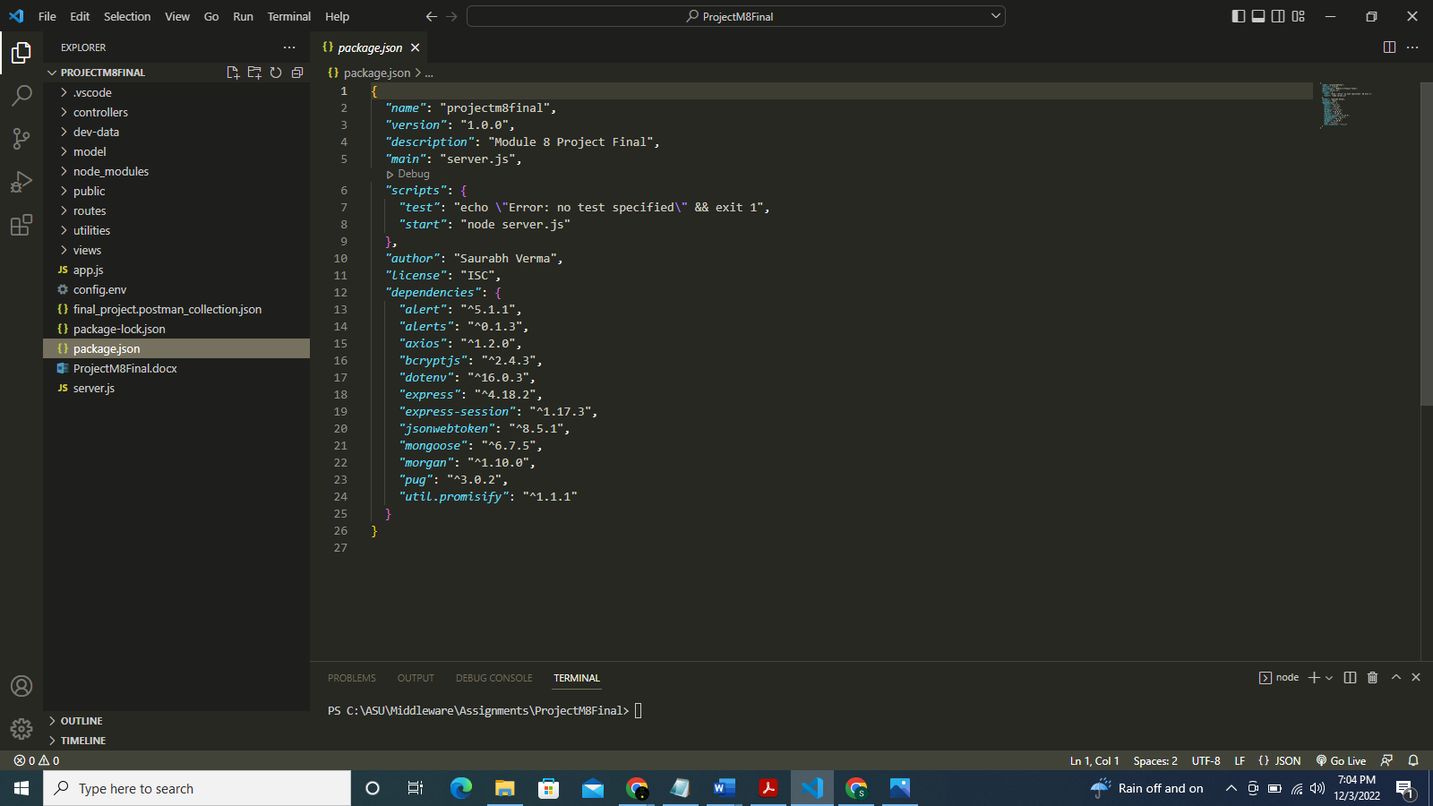

**Config.env file:**

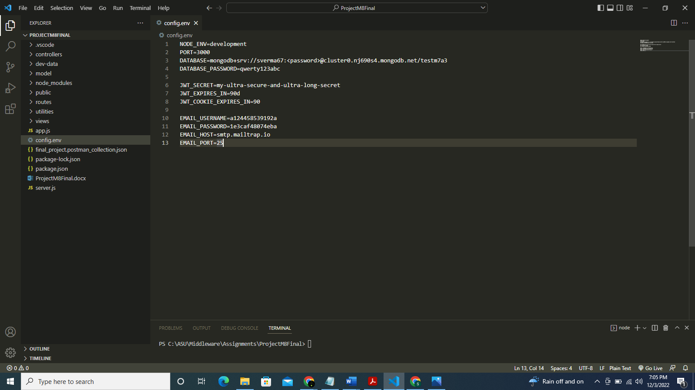

**Server.js file:**

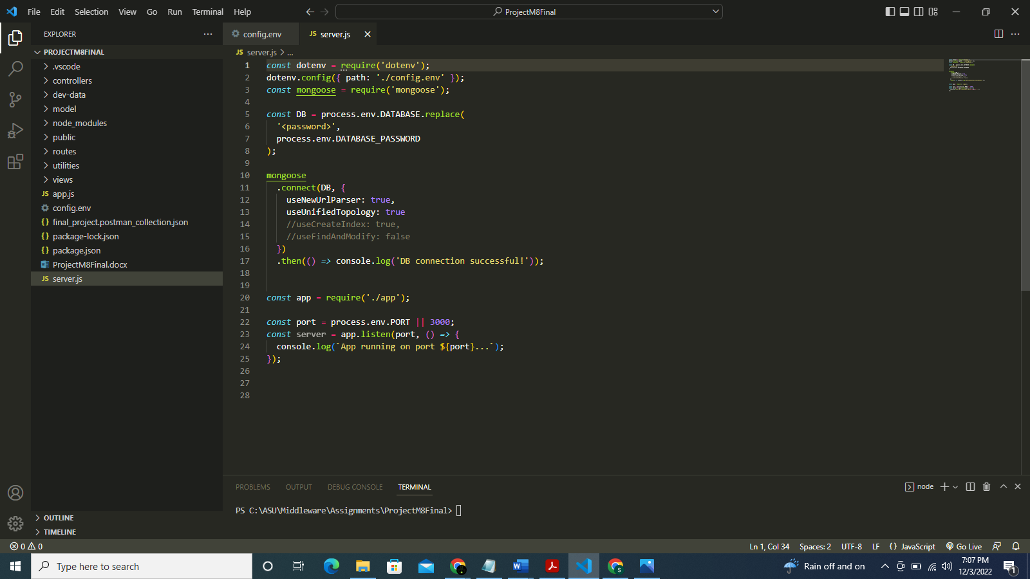

**App.js file:**

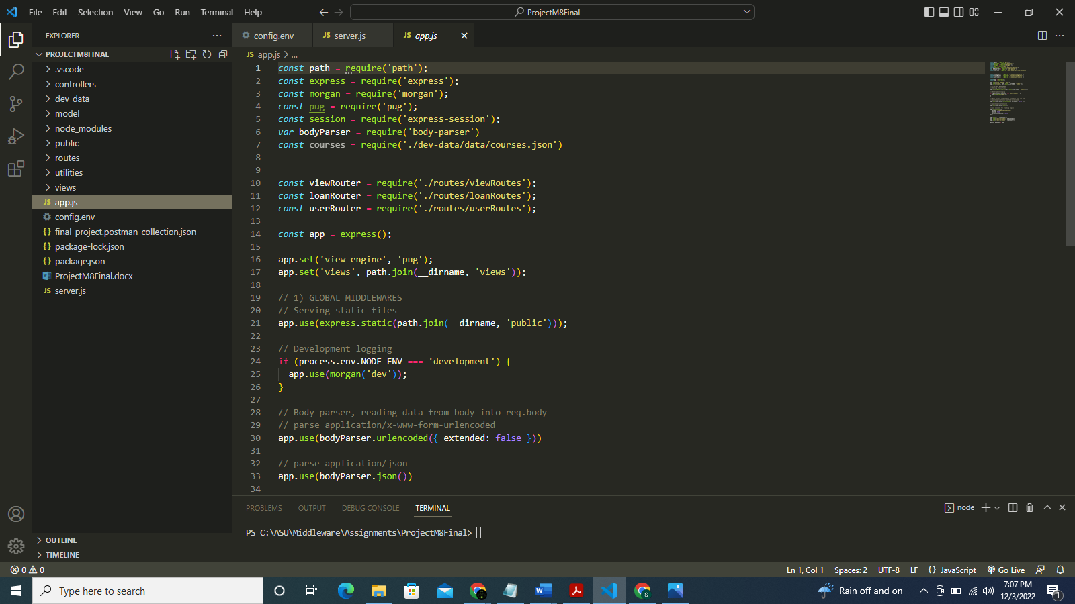

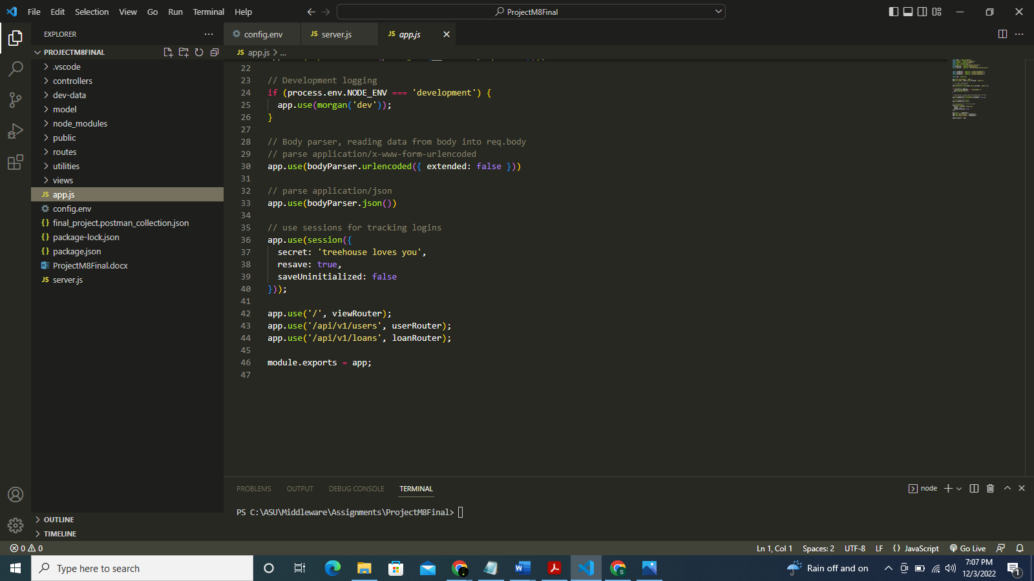

**authController.js file:**

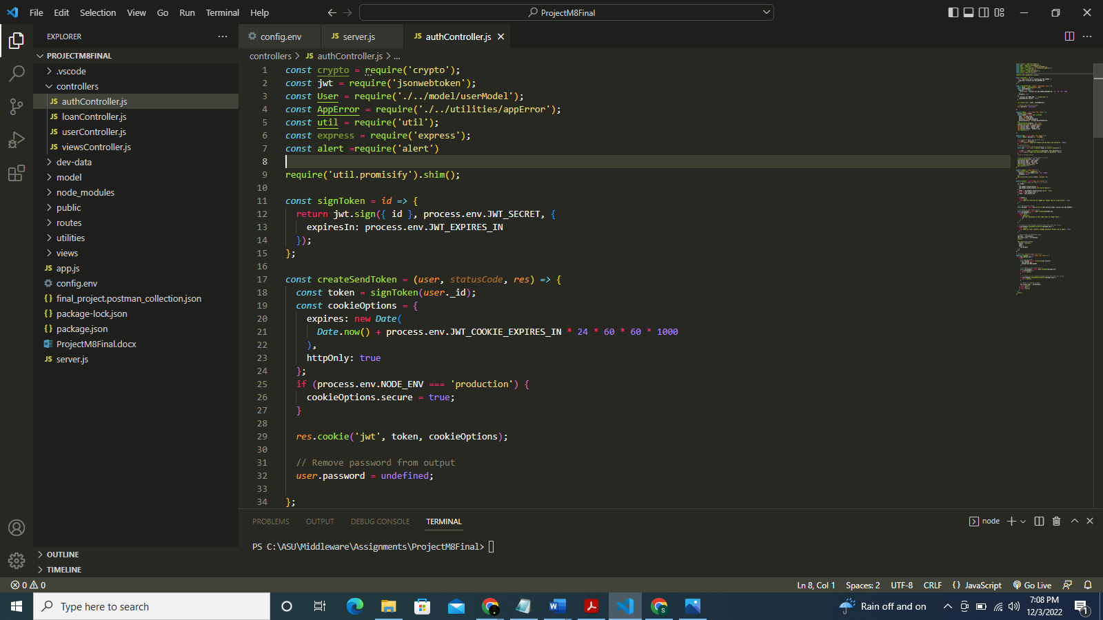

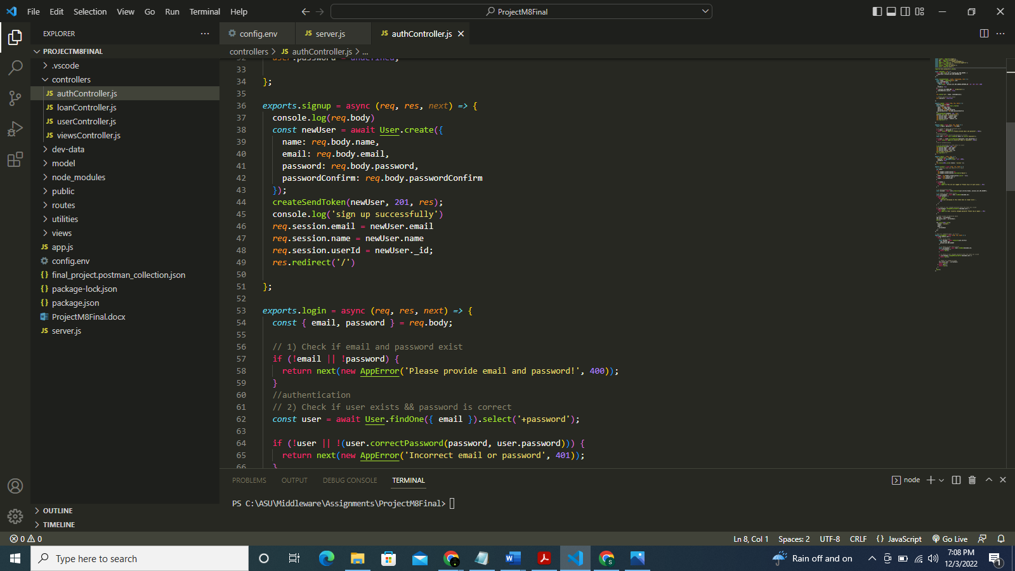

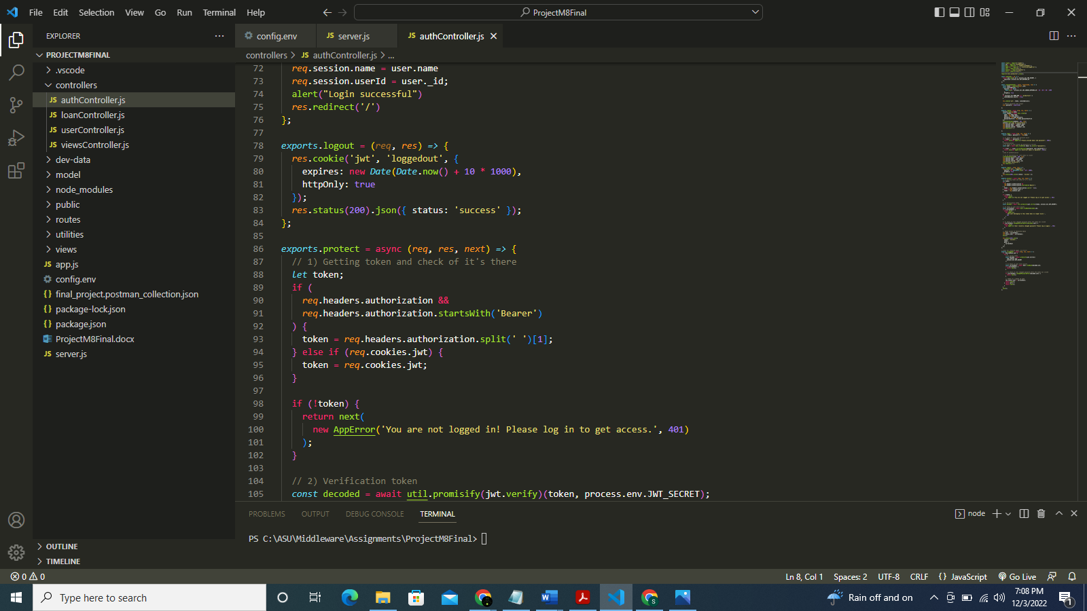

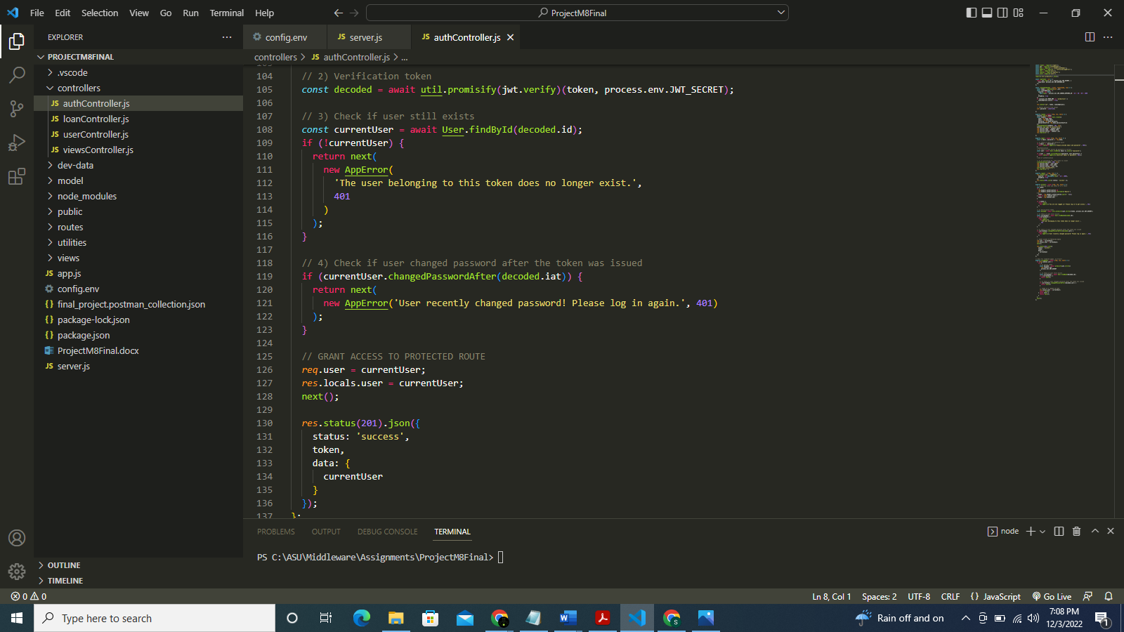

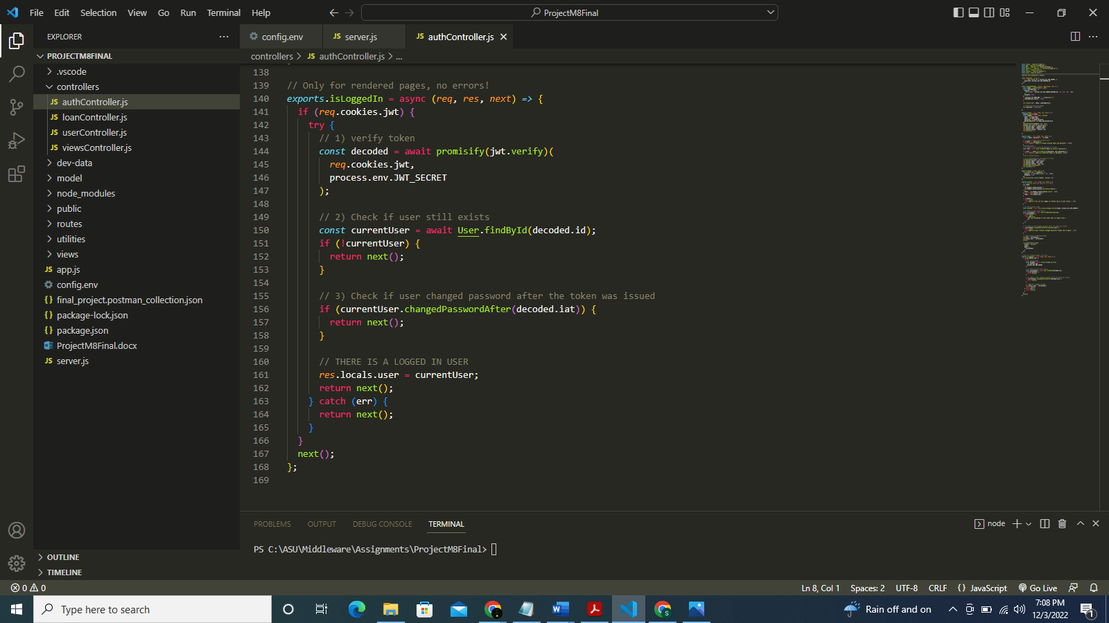

**loanController.js file:**

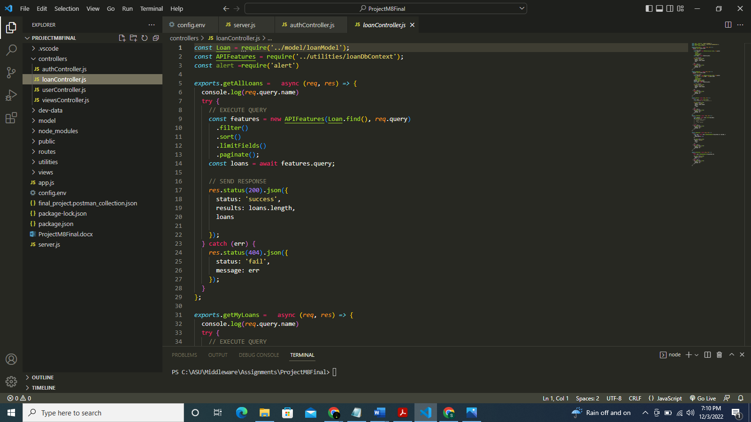

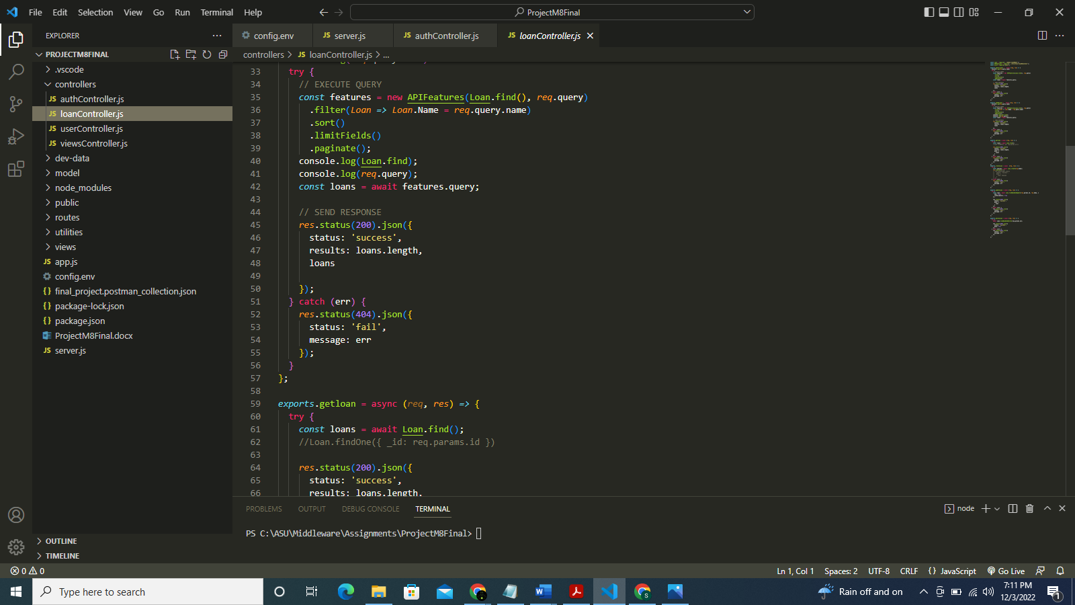

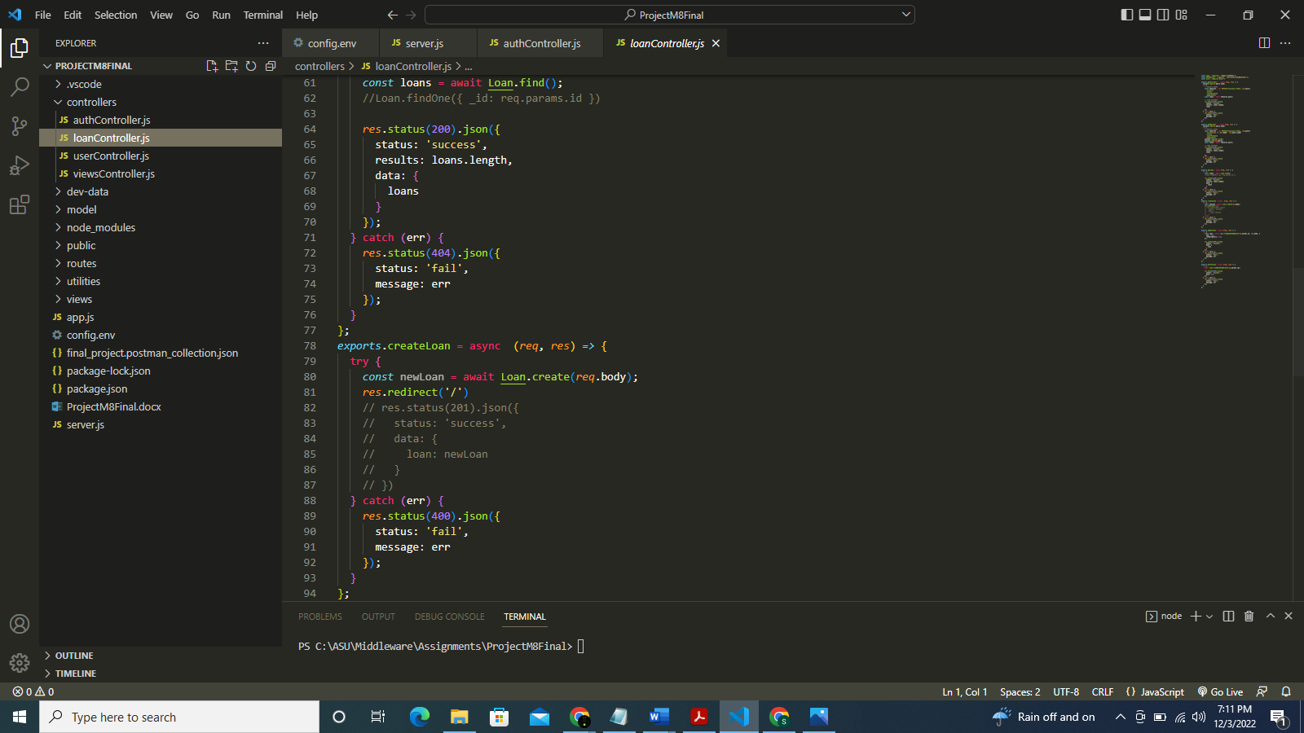

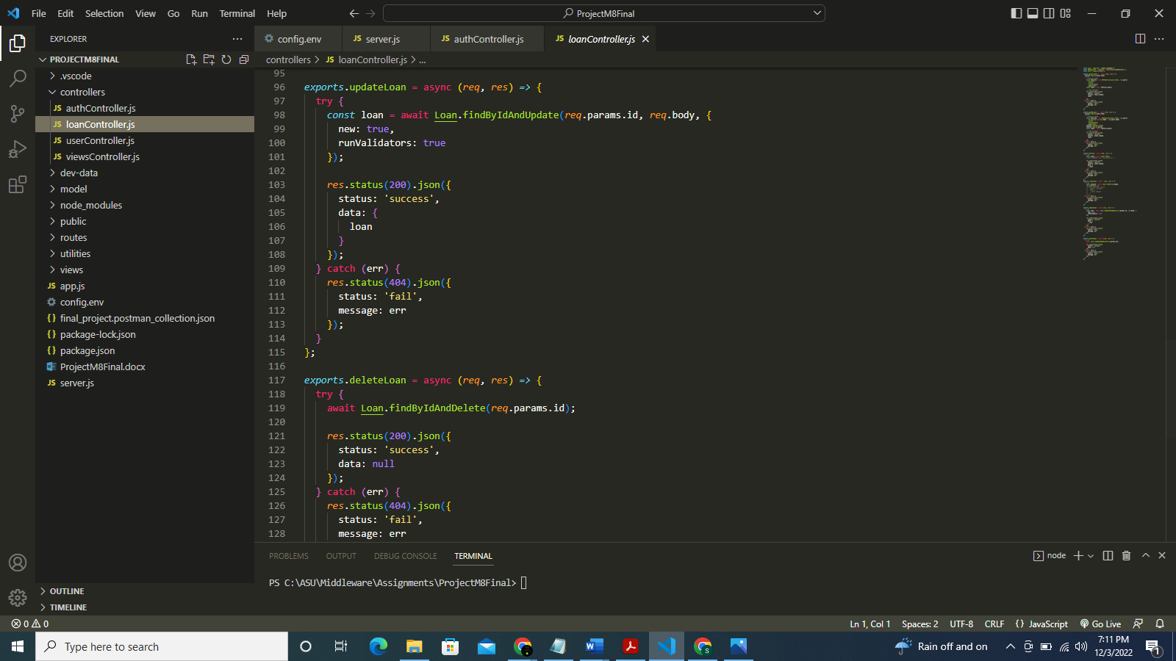

**userController.js file:**

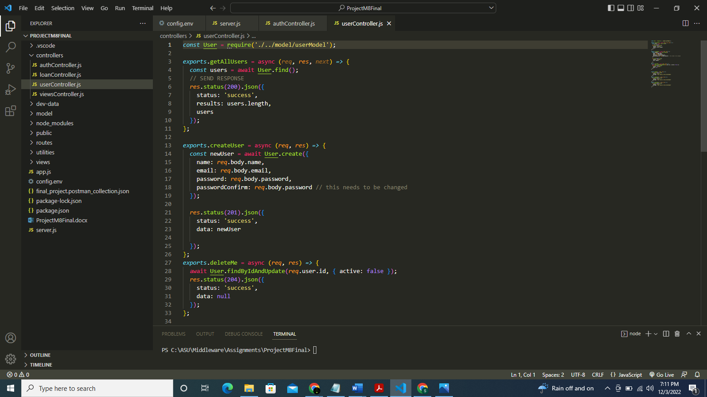

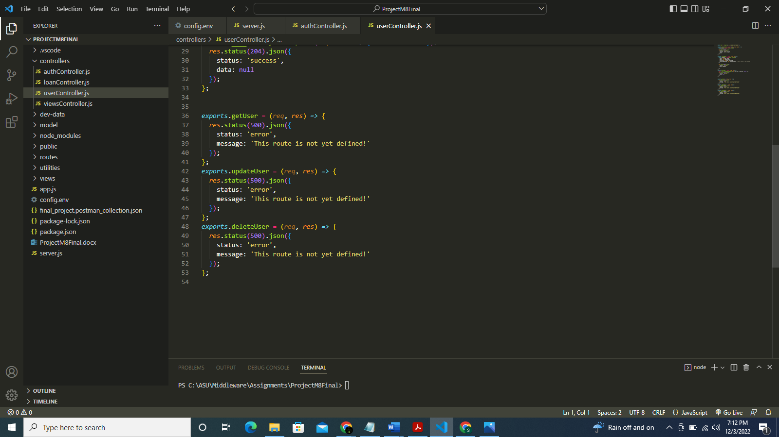

**viewController.js file:**

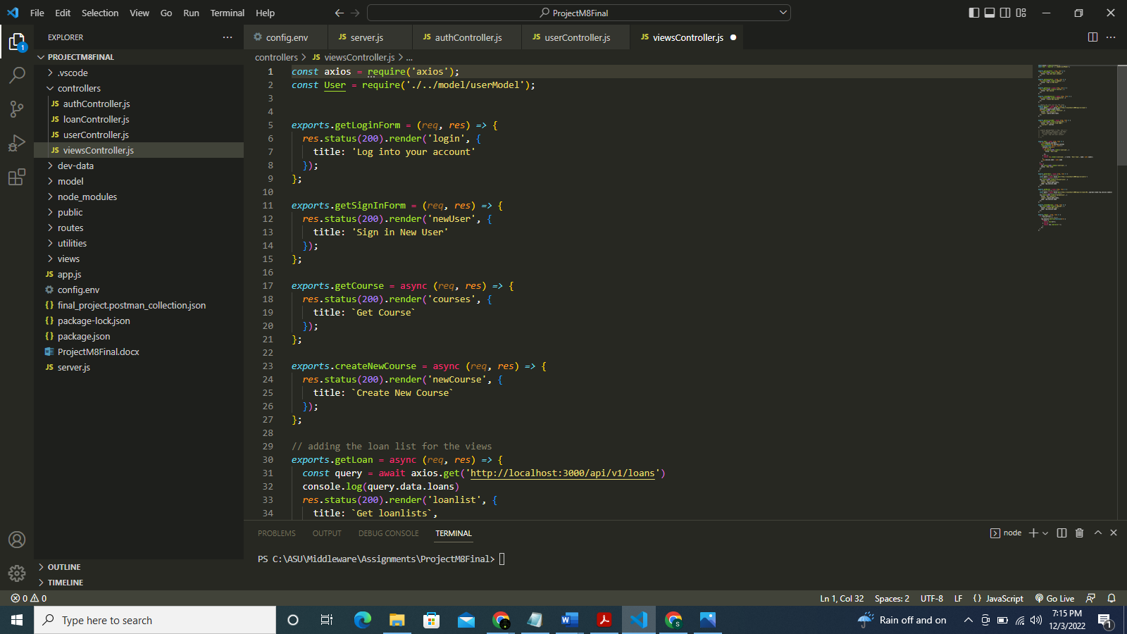

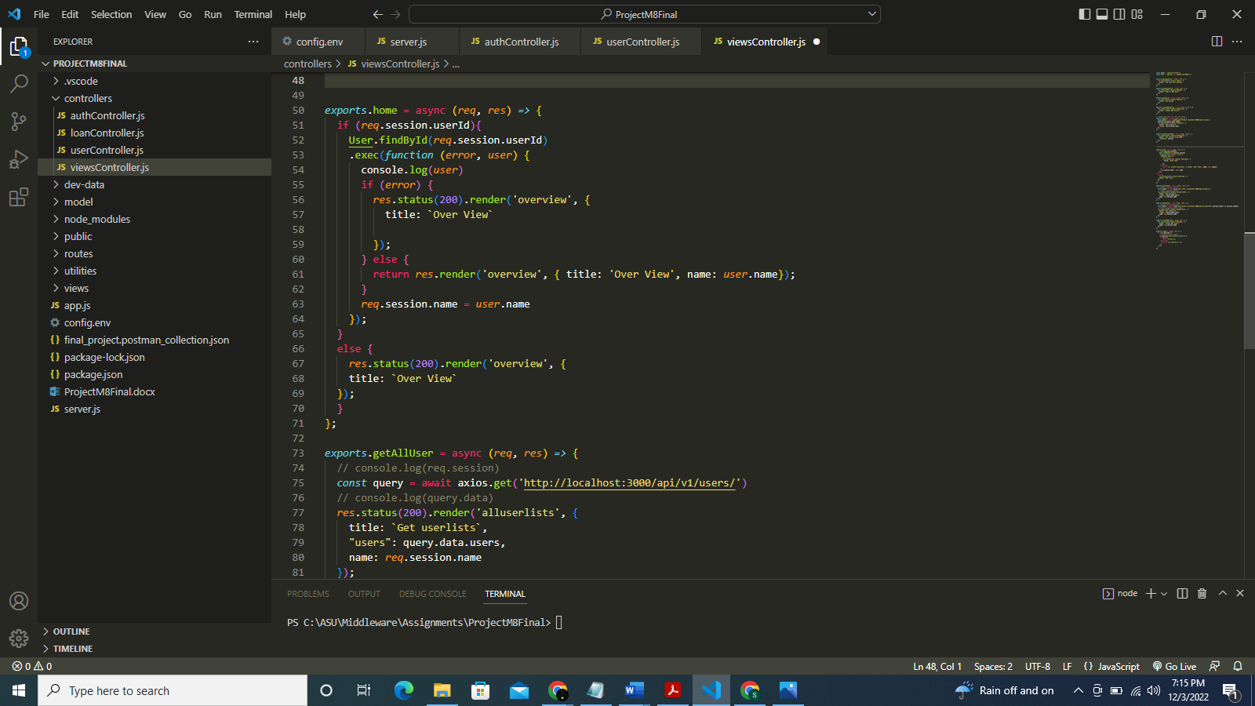

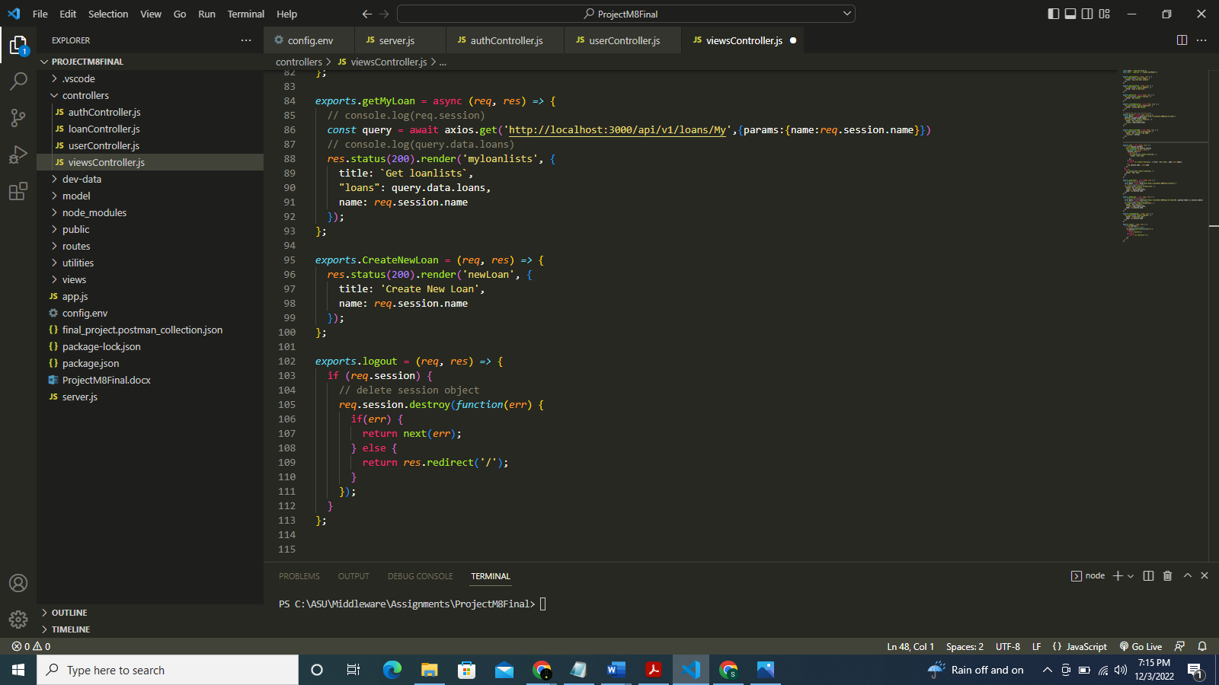

**loanModel.js file:**

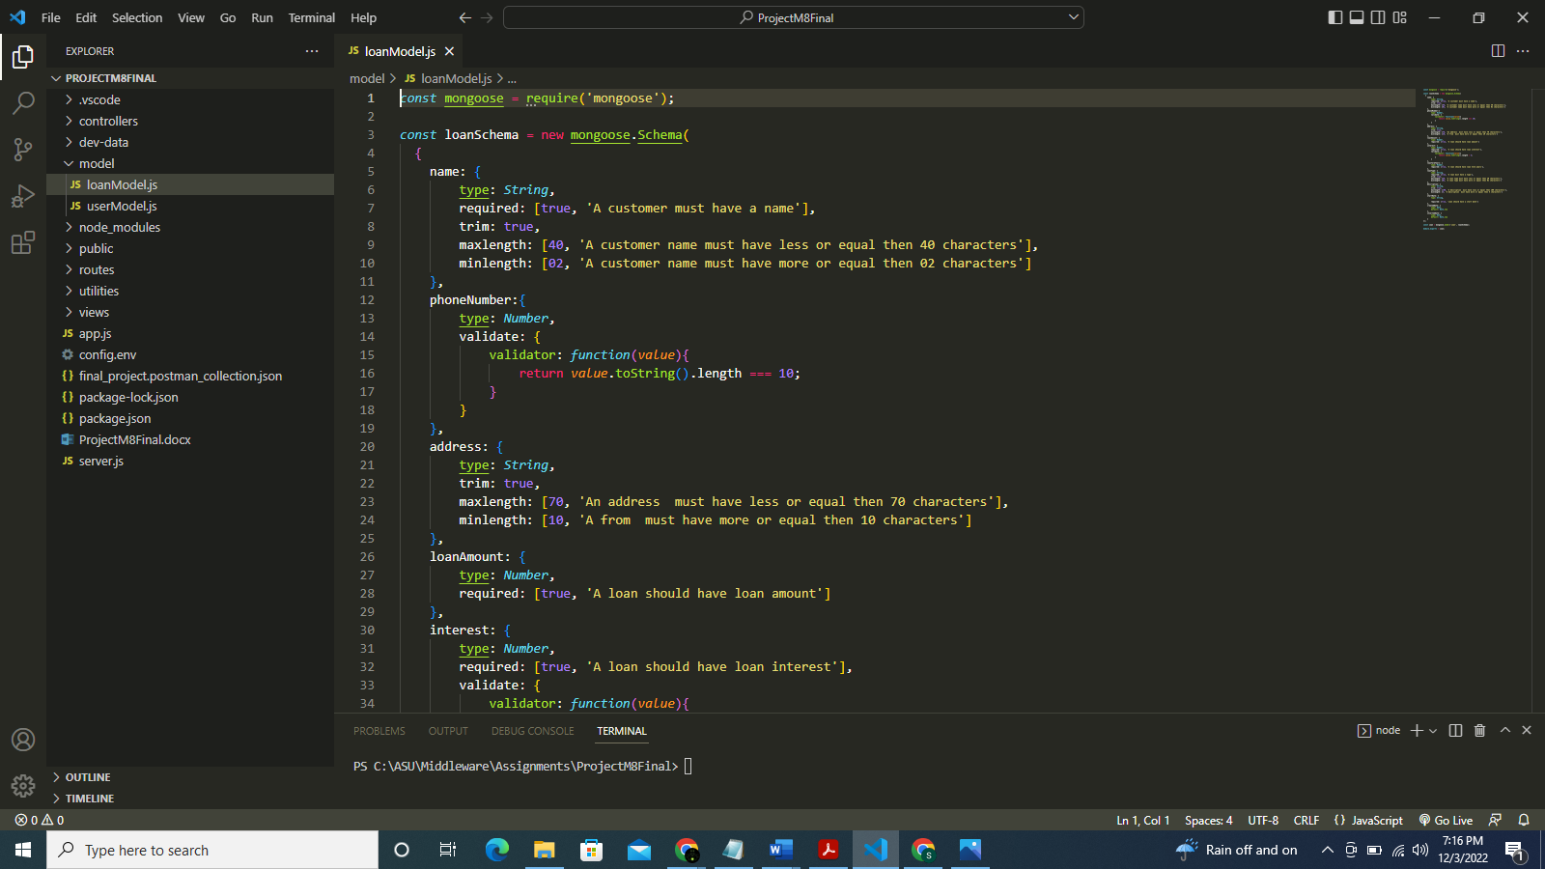

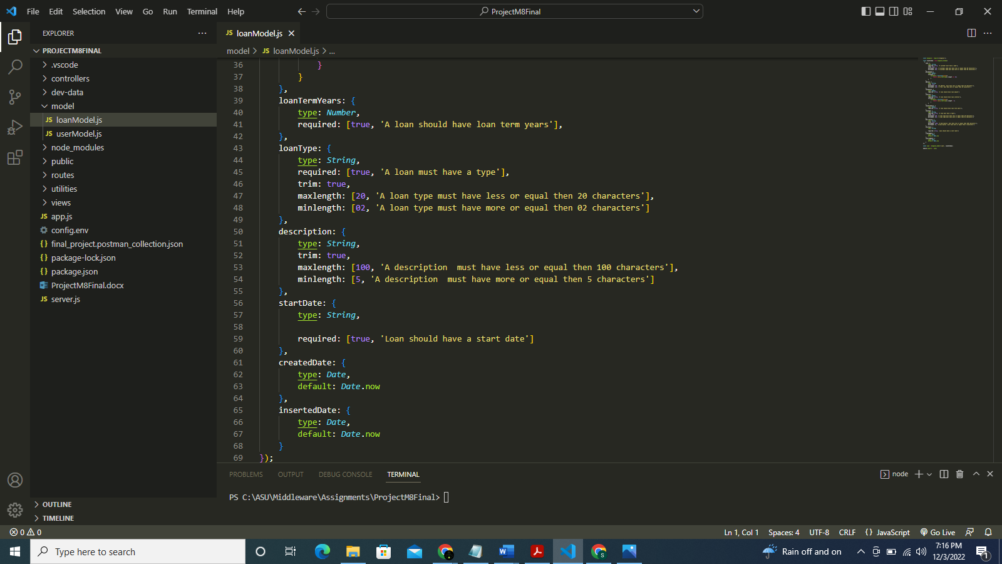

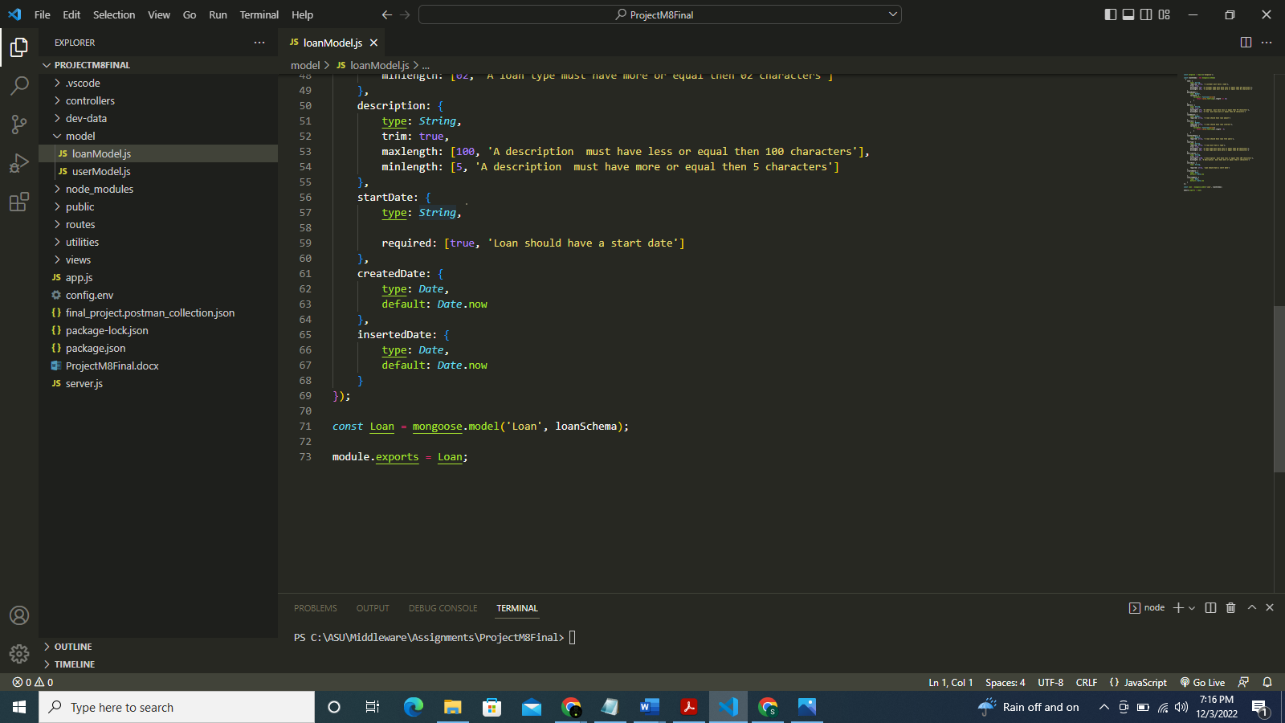

**userModel.js file:**

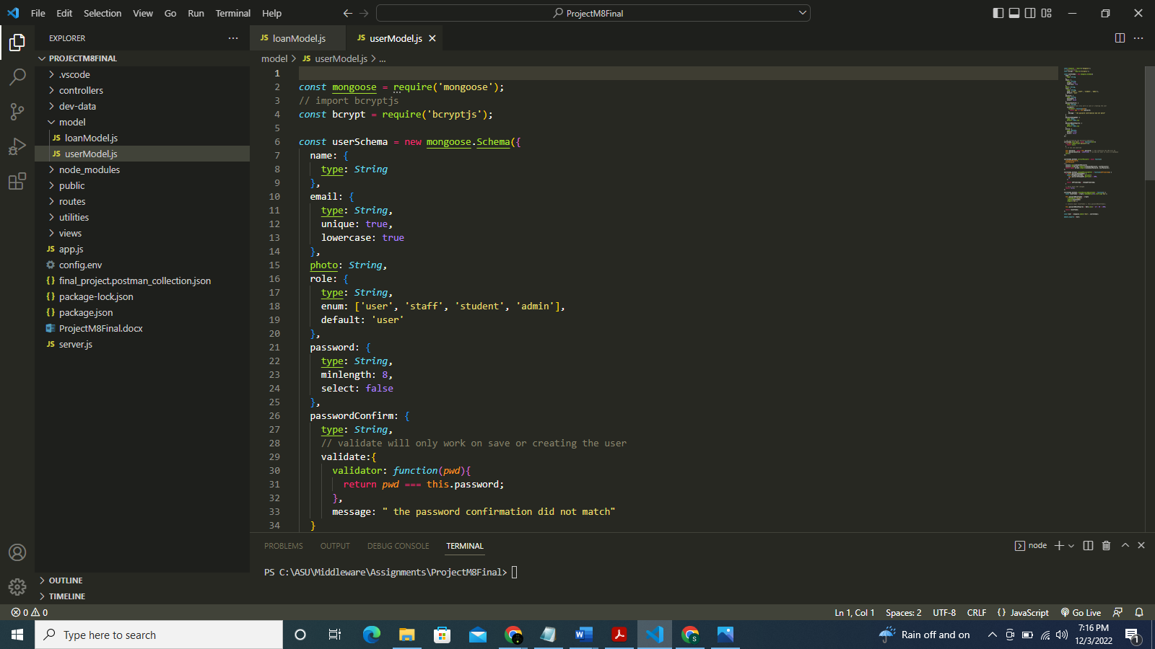

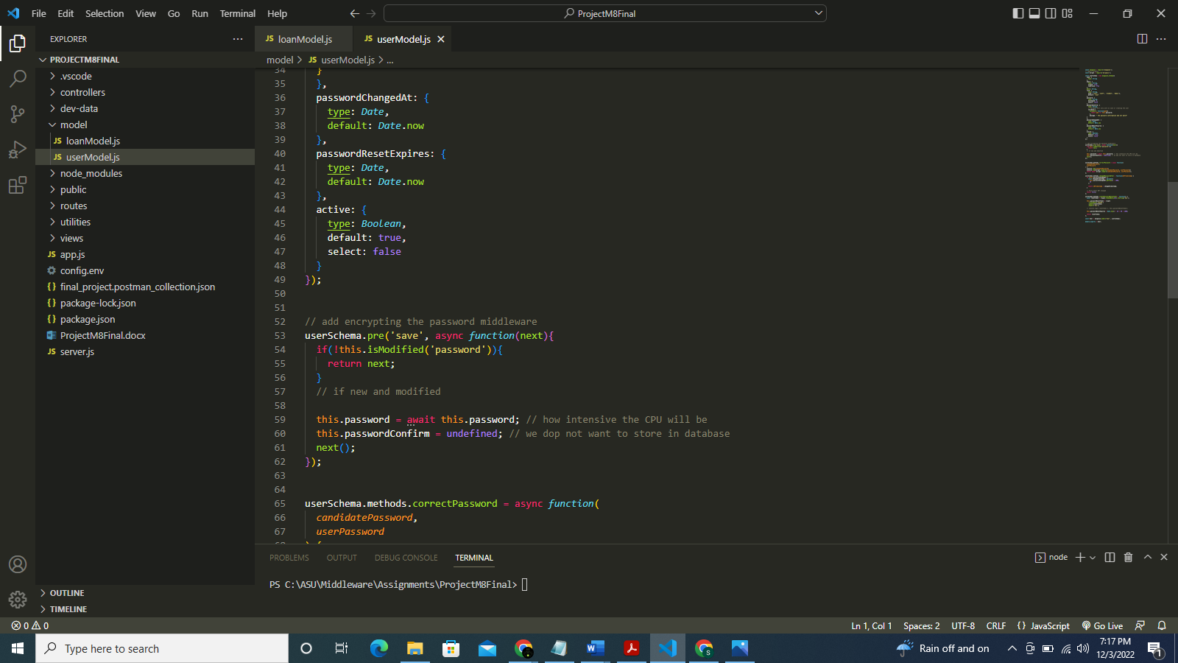

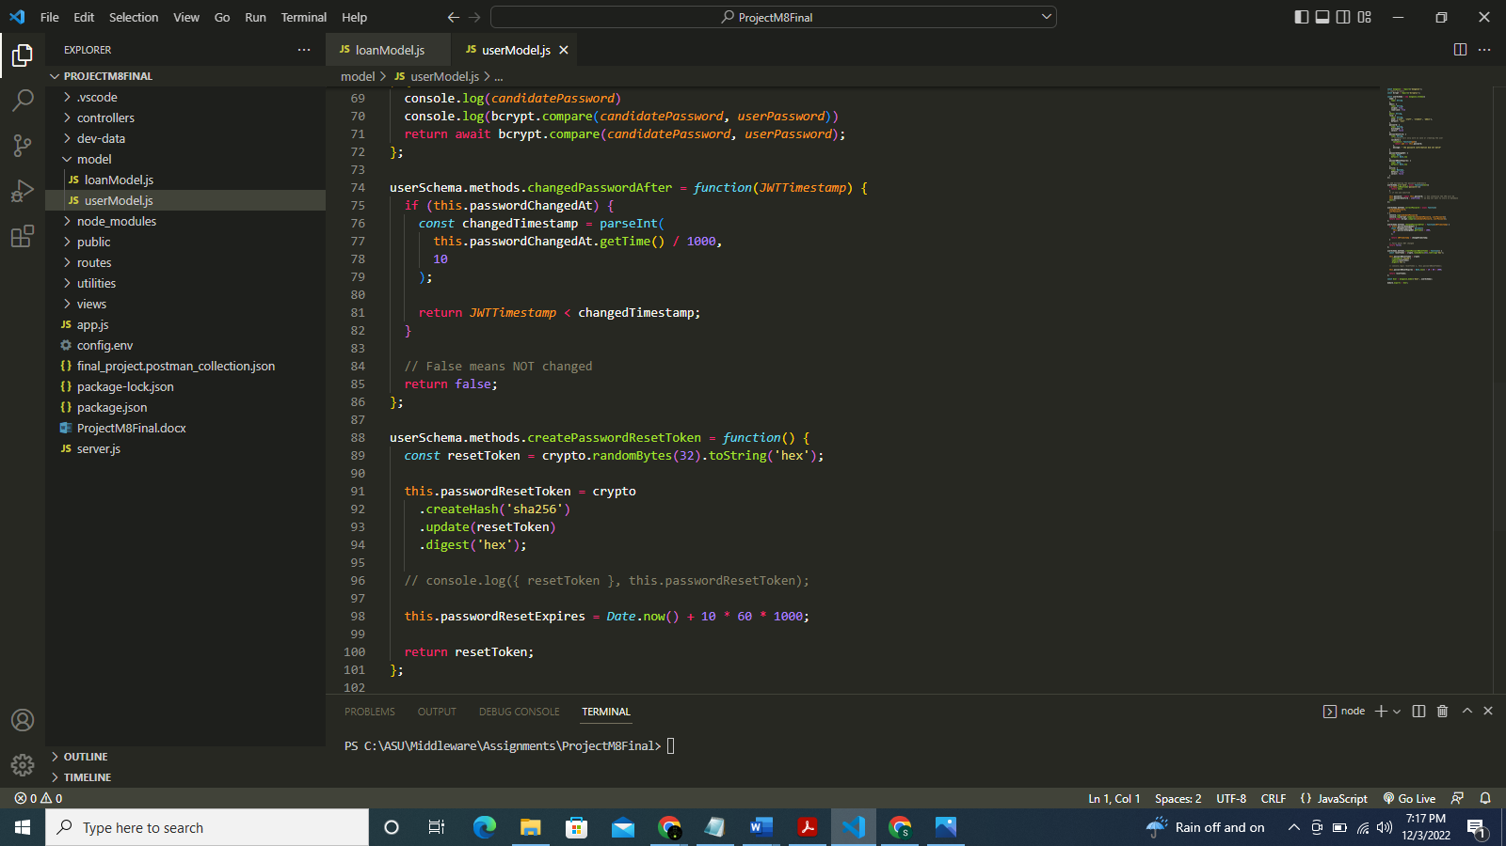

**loanRoutes.js file:**

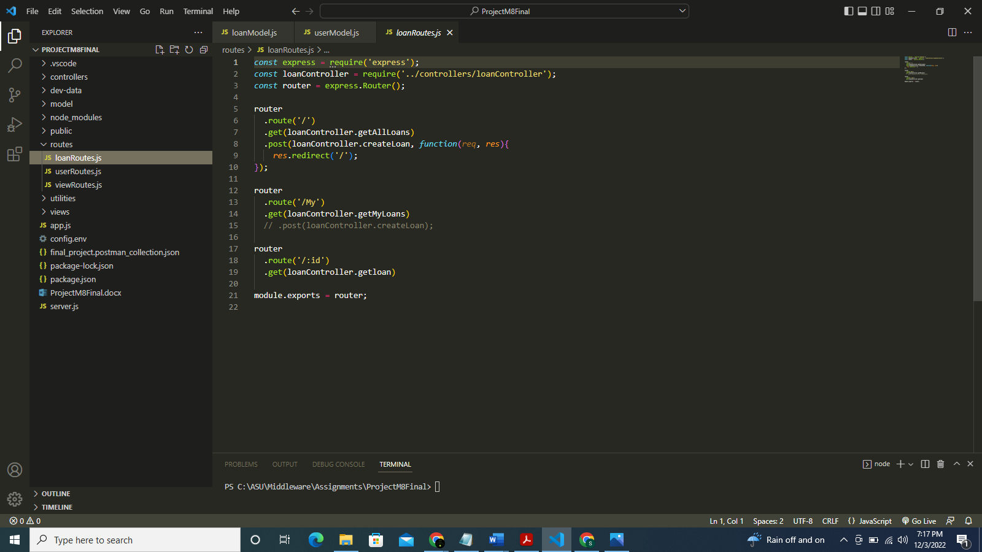

**userRoutes.js file:**

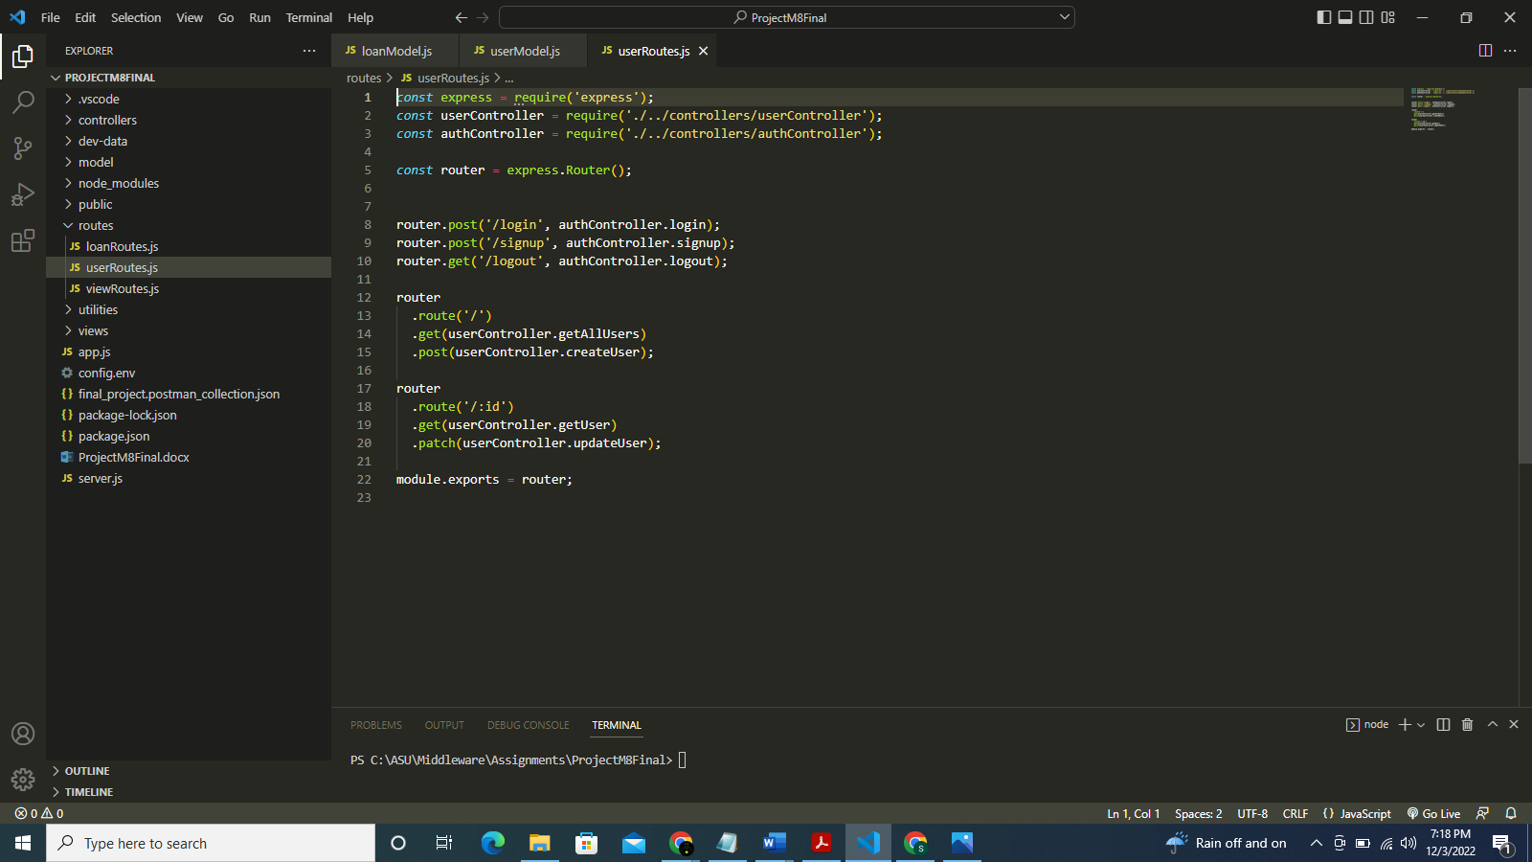

**viewRoutes.js file:**

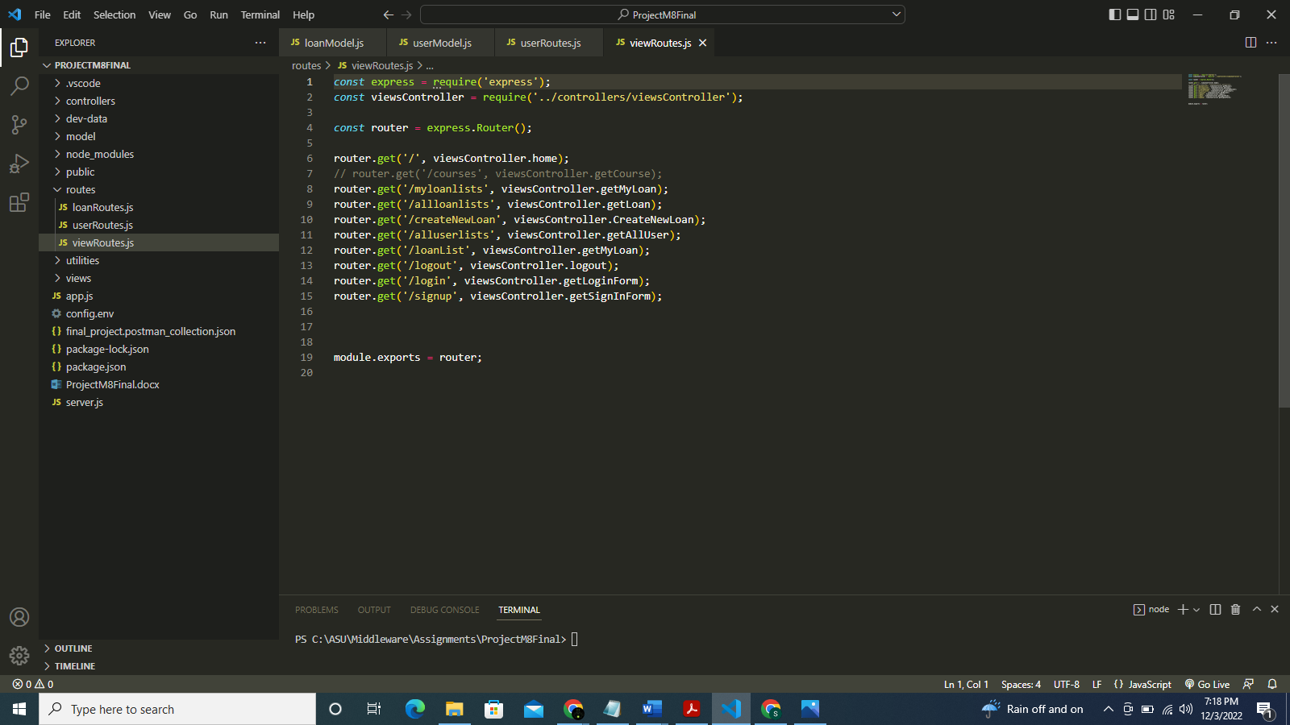

**Now, all the html and pug files:**

**Login.html file:**

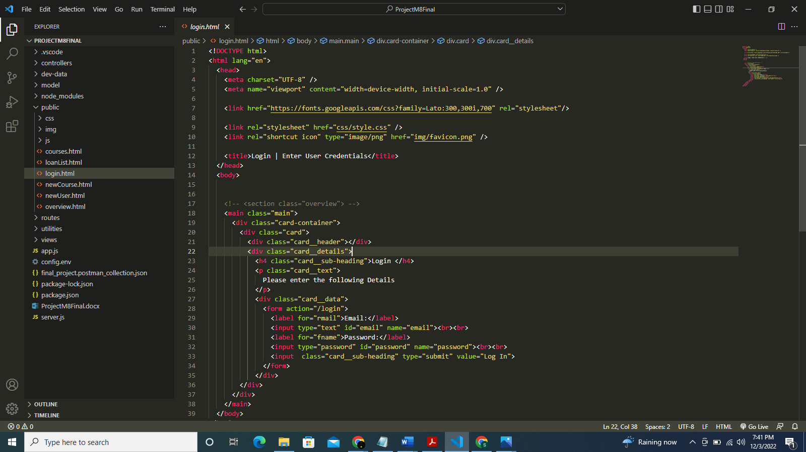

**newUser.html:**

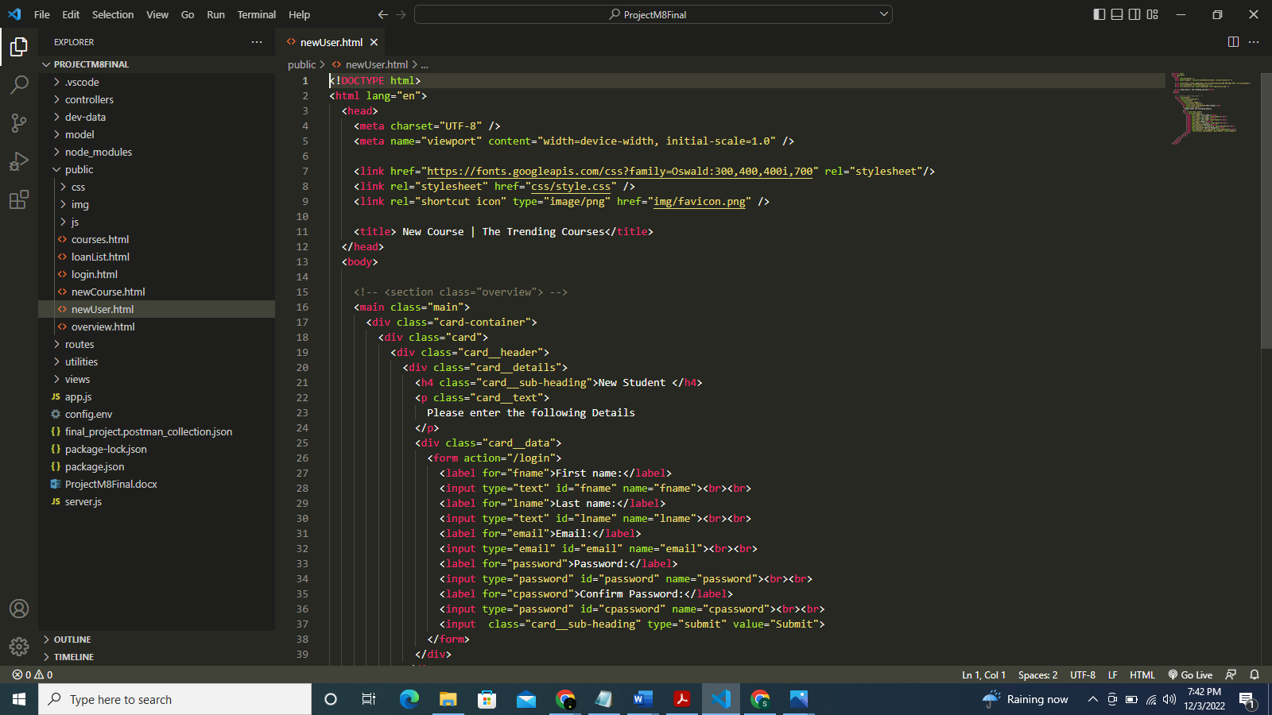

**Overview.html file:**

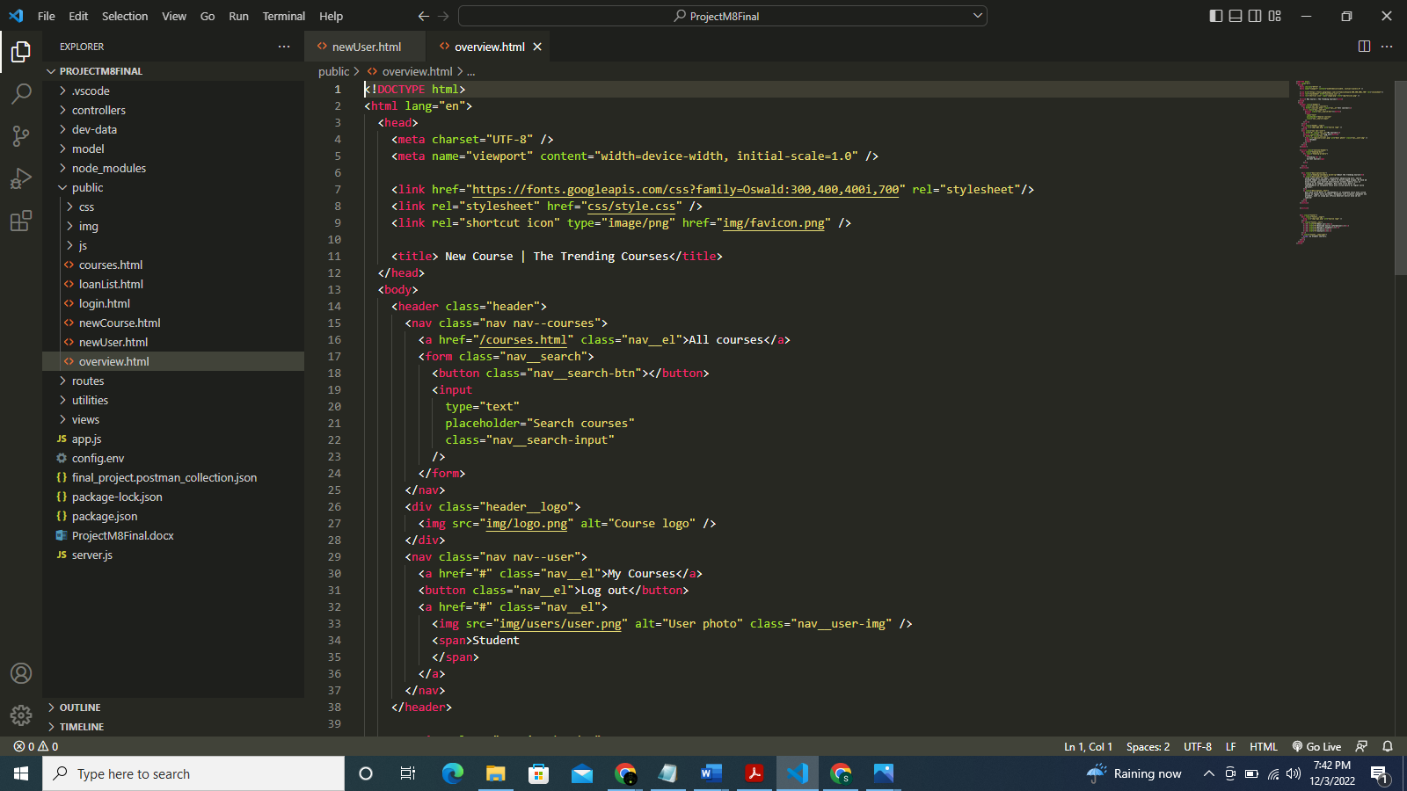

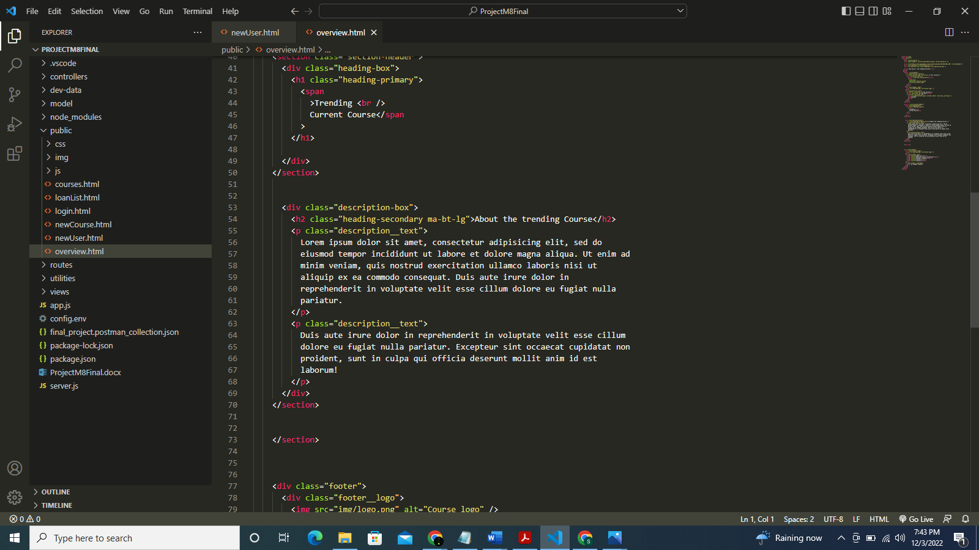

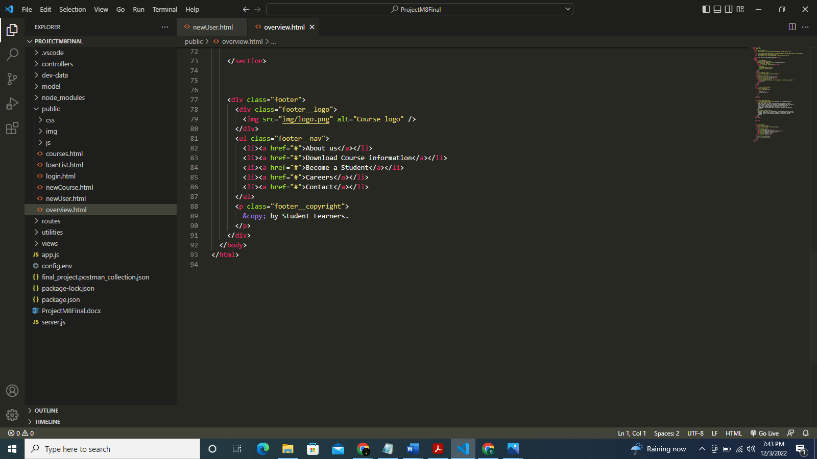

**loanList.html file:**

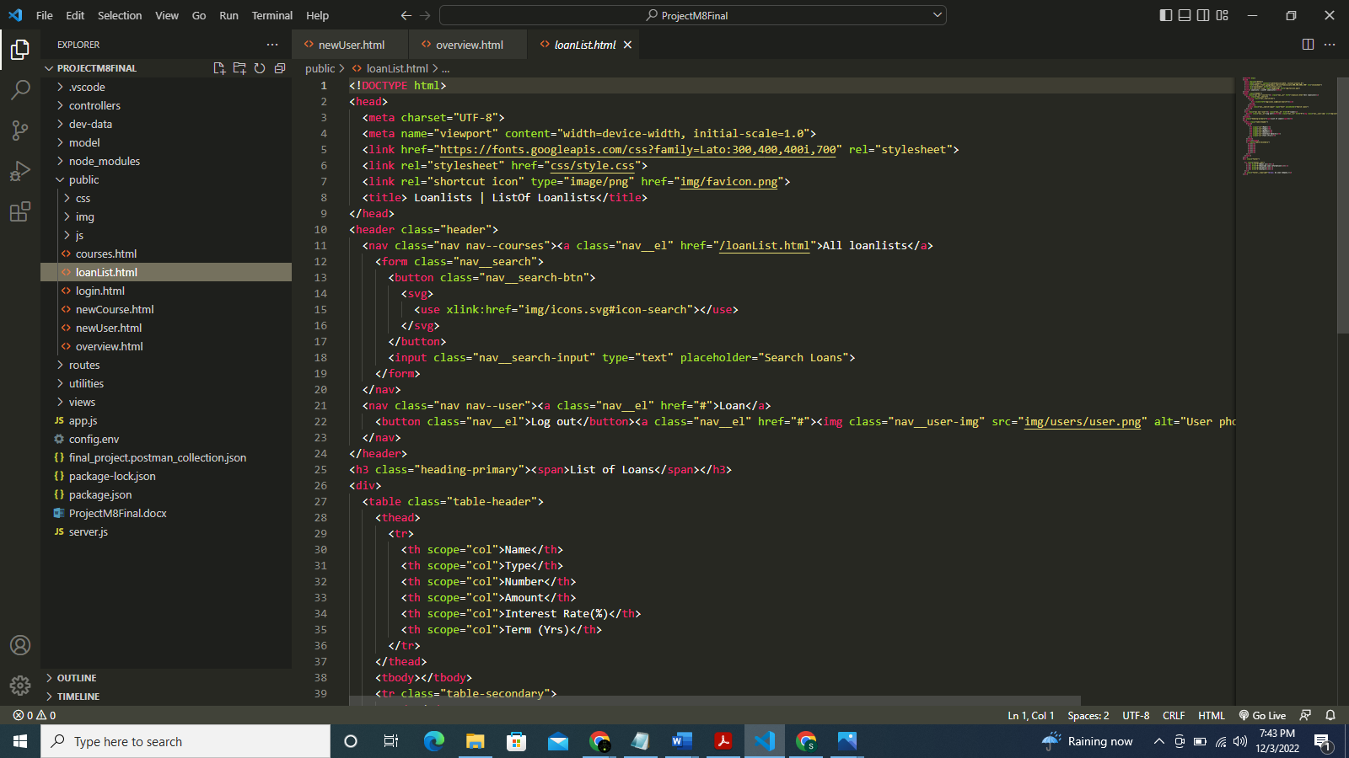

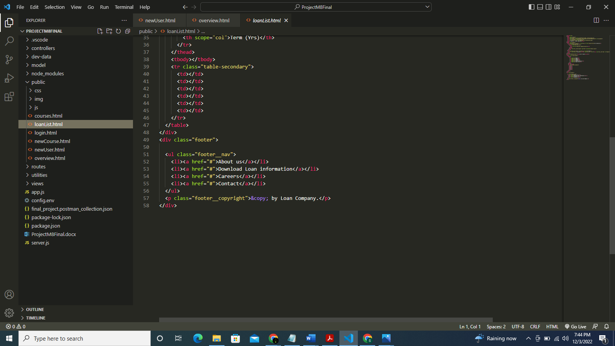

**Now PUG files:**

**Login.pug file:**

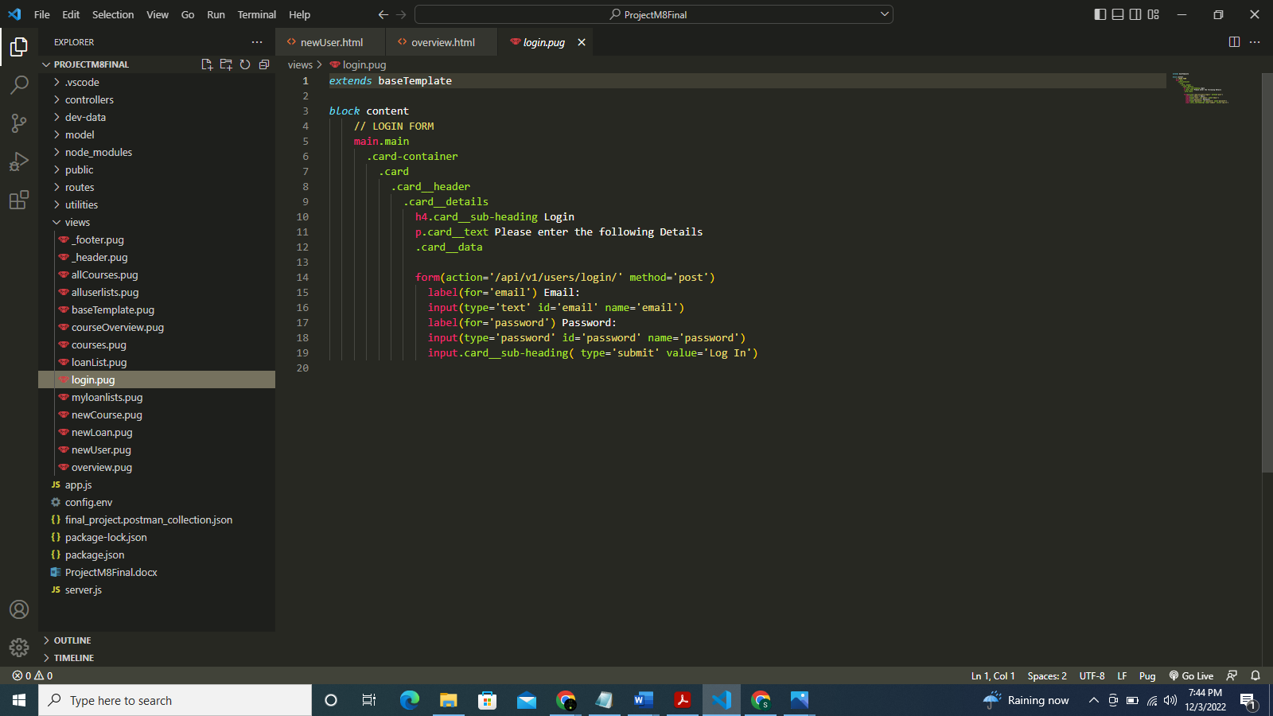

**newUser.pug file:**

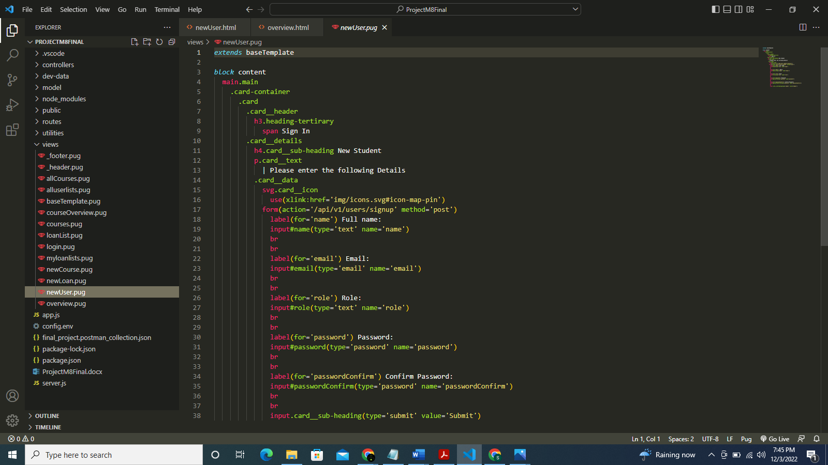

**newLoan.pug file:**

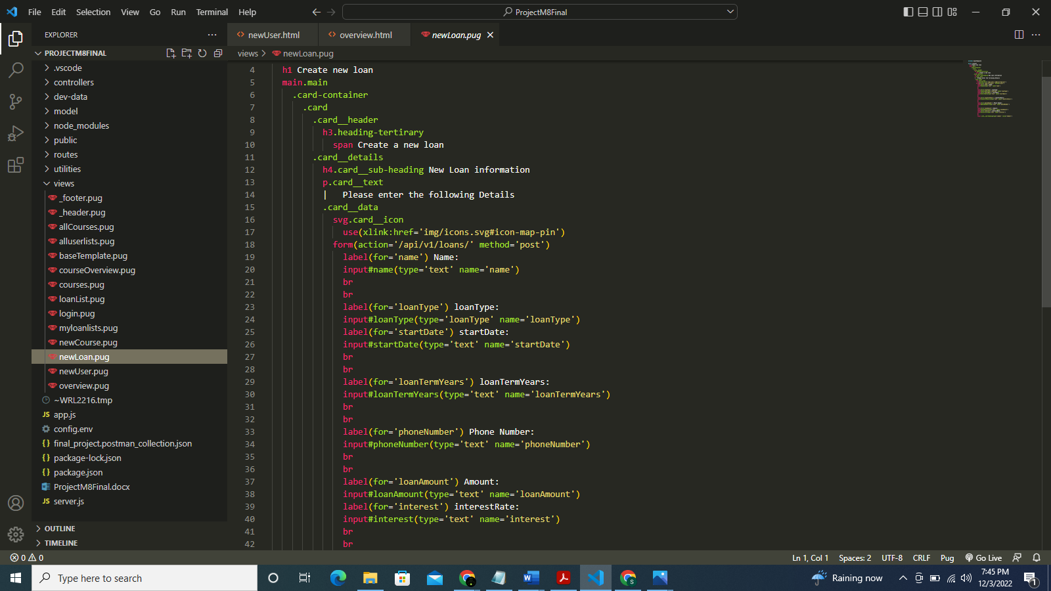

**loanList.pug file:**

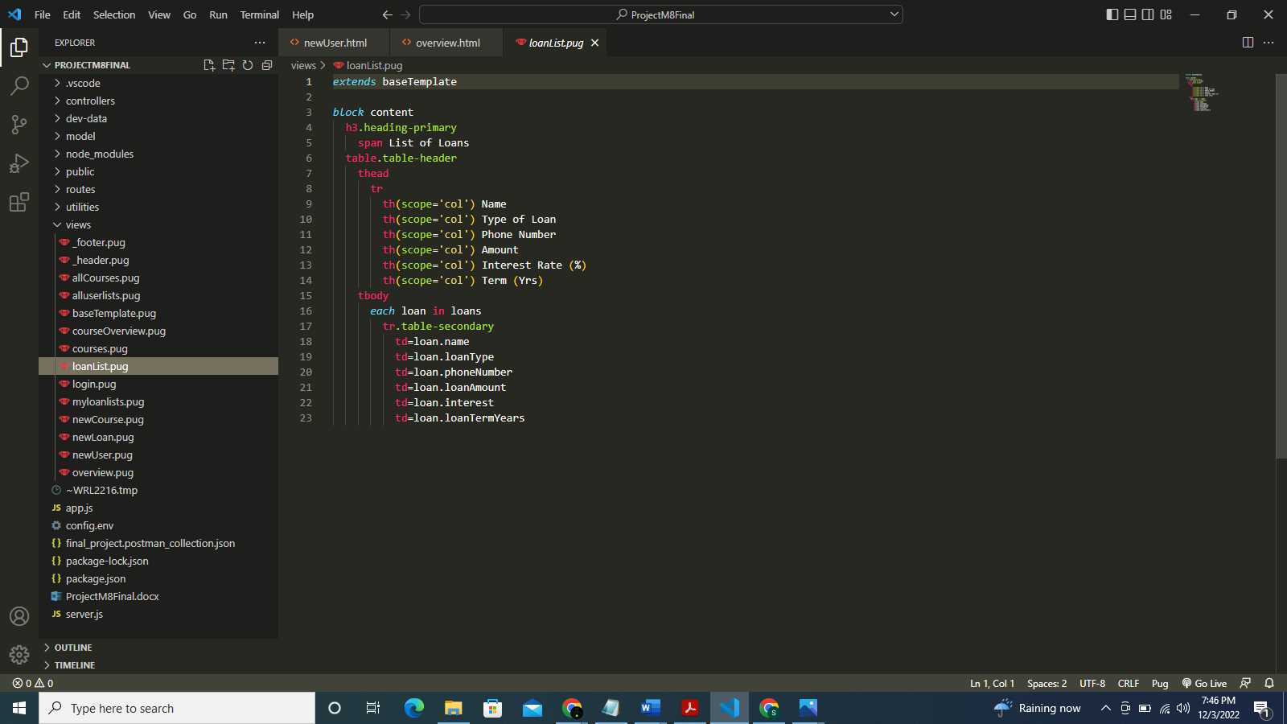

**Project compiled successfully without any errors:**

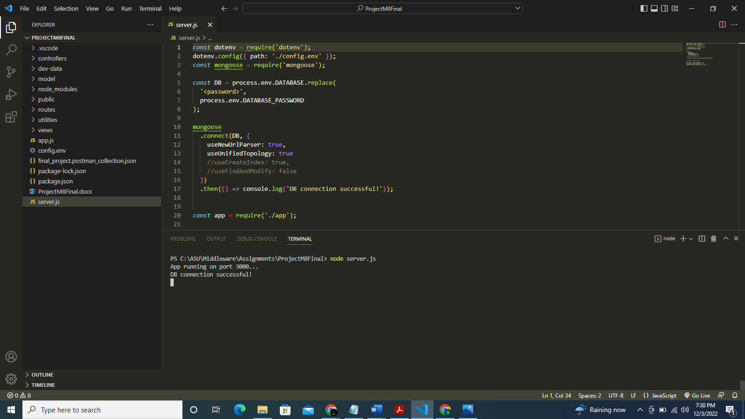

**Now the flow charts:**

**A: User Interface (Front End)**

1. **Create New User**

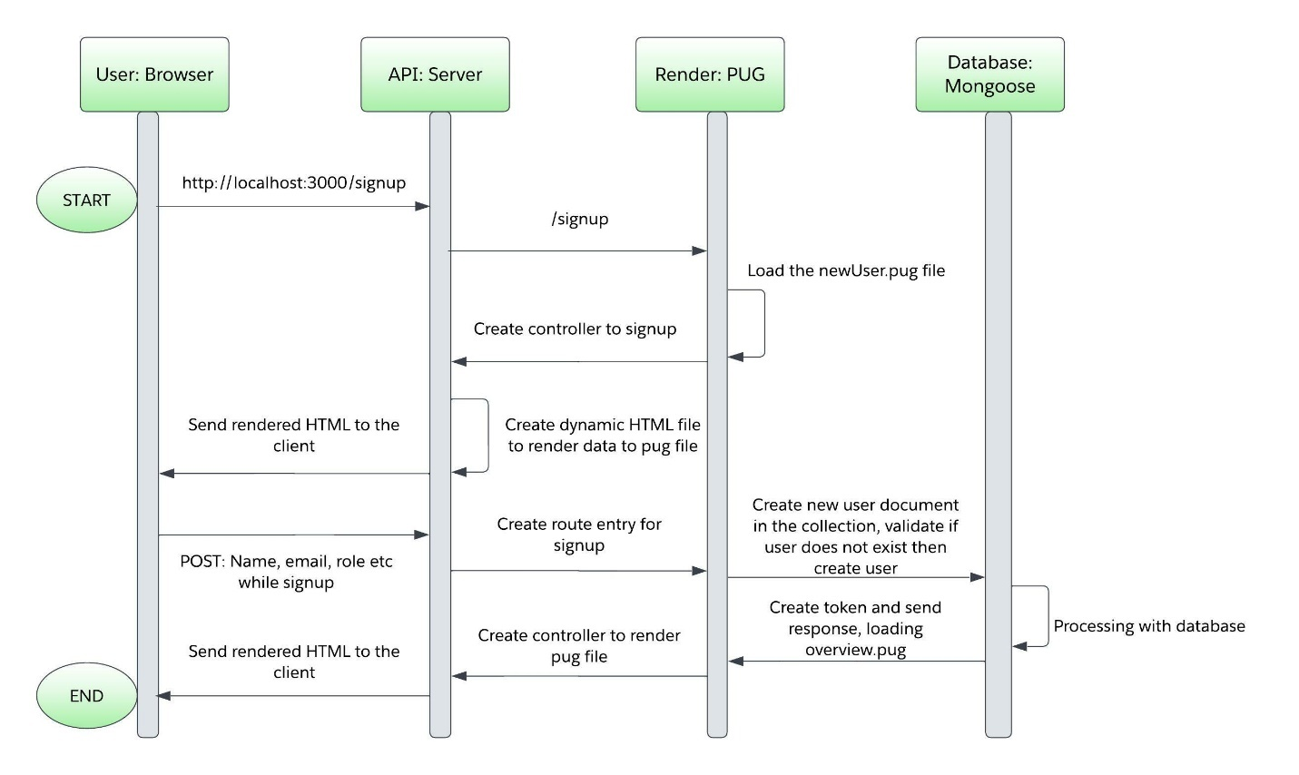

1. **Login Current User**

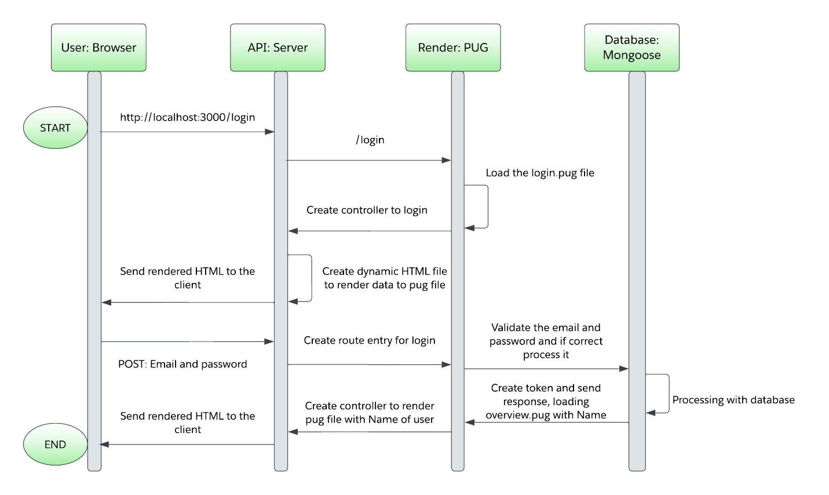

1. **Create New Loans**

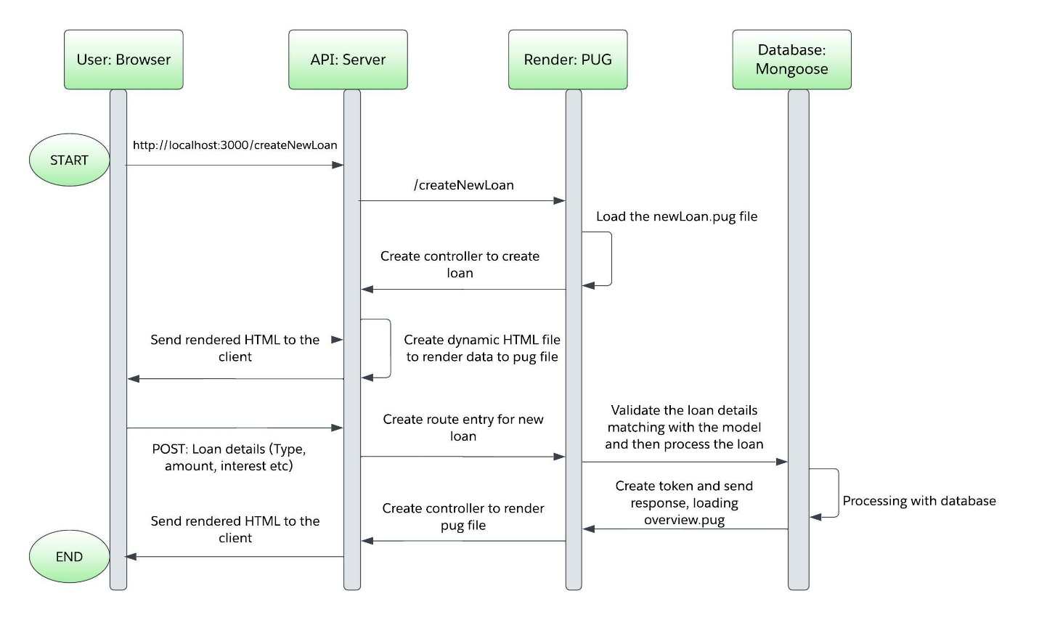

**4. List Loan Details**

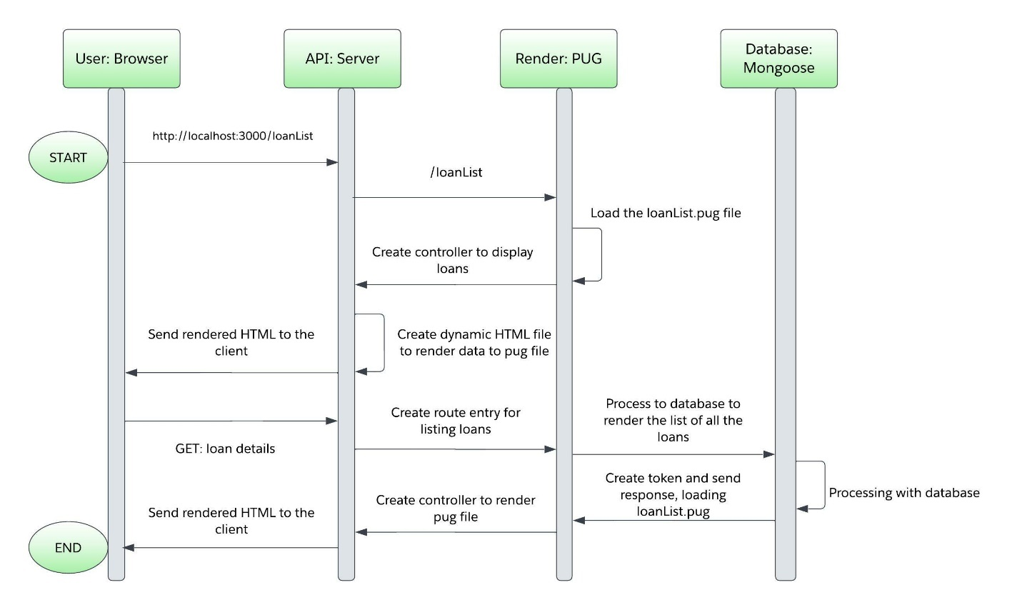

1. **Loan Database**

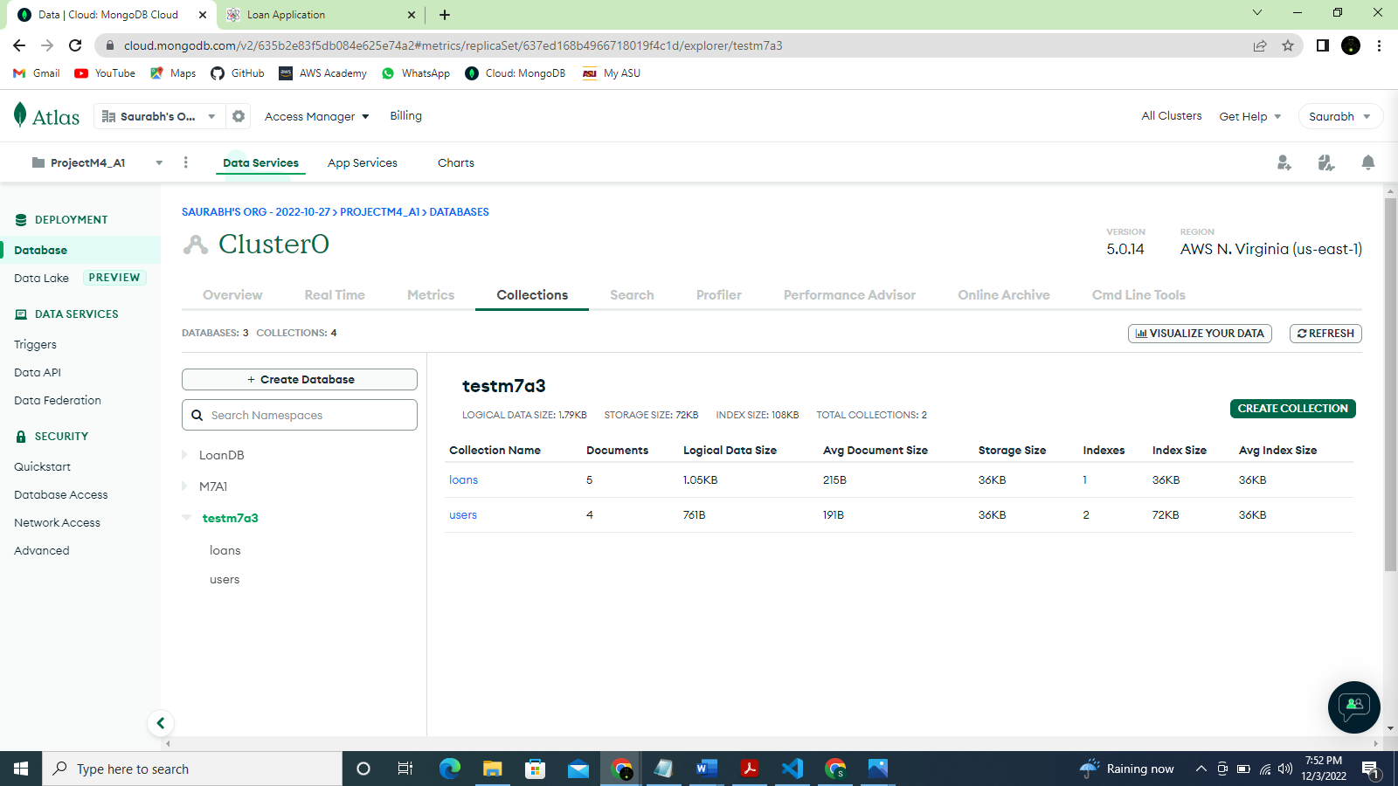

1. **Loan collection**

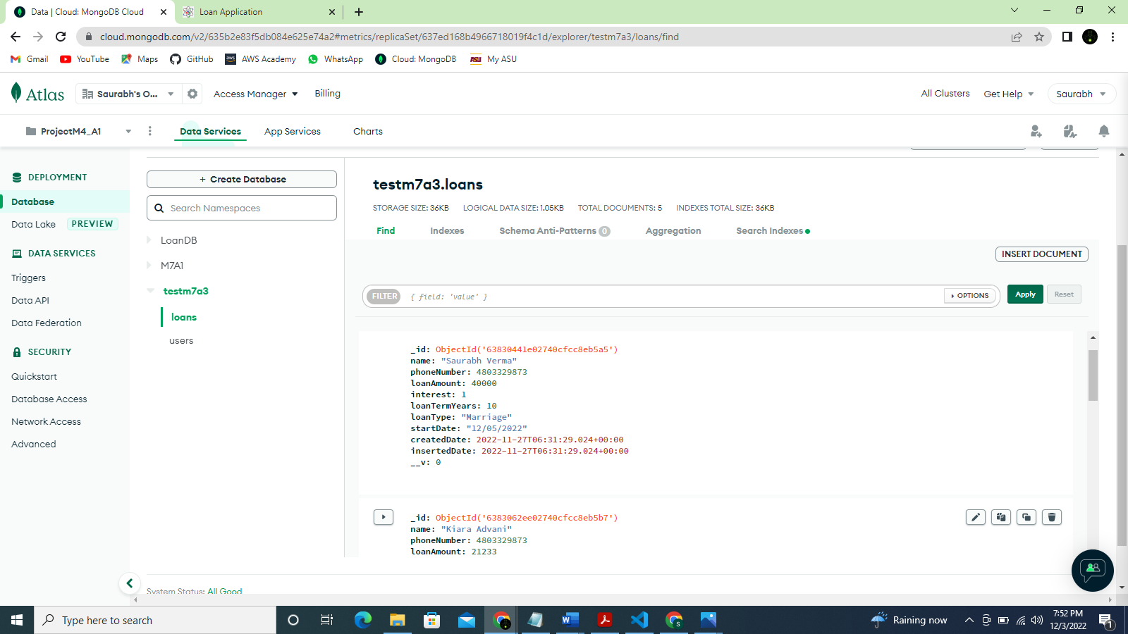

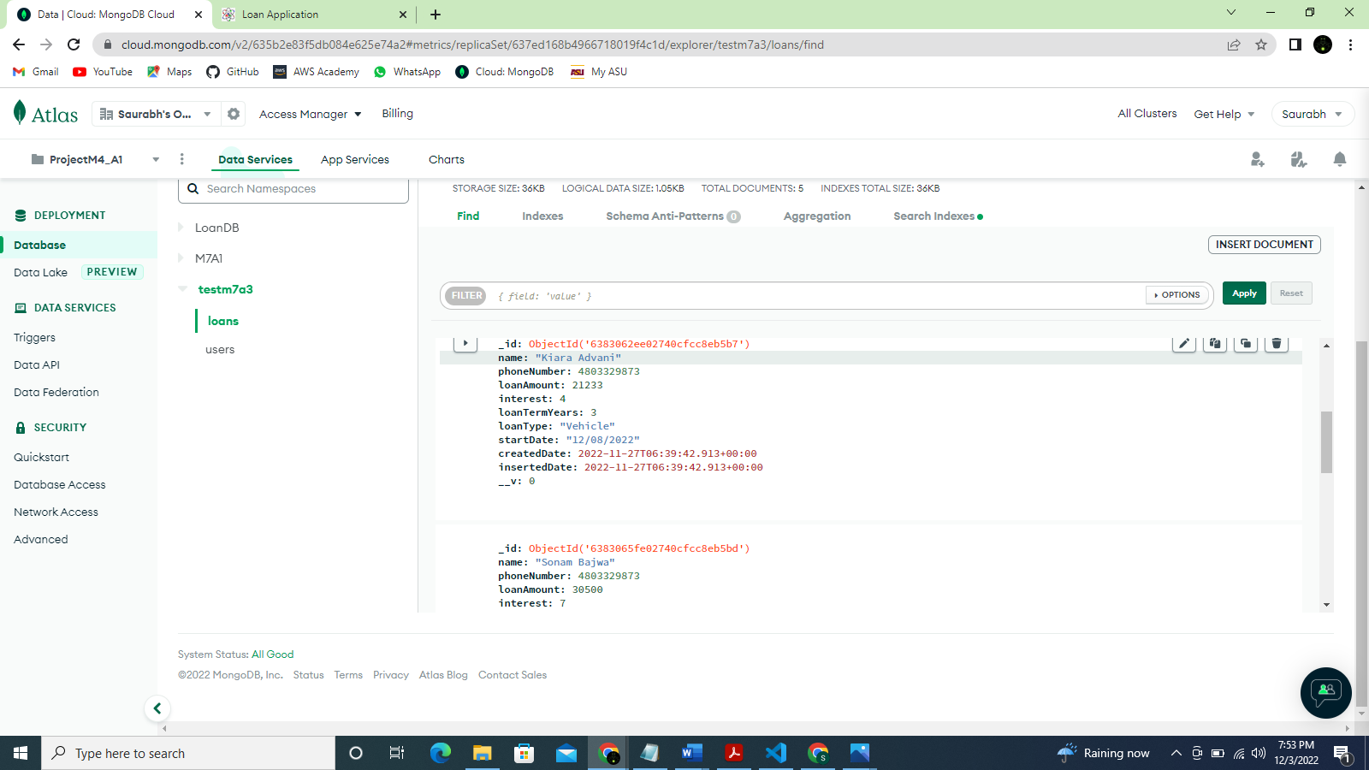

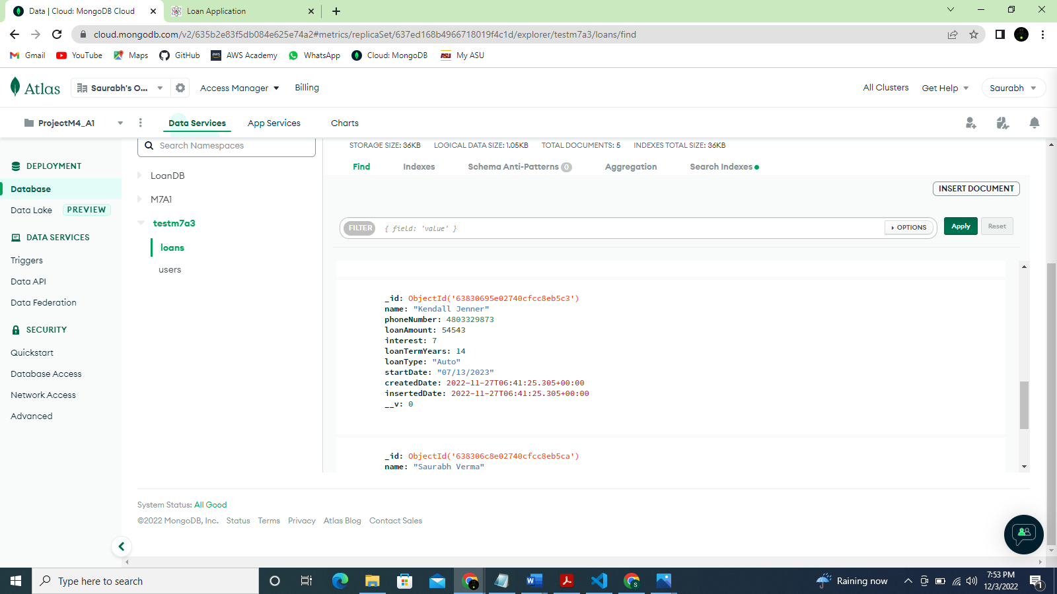

1. **User collection**

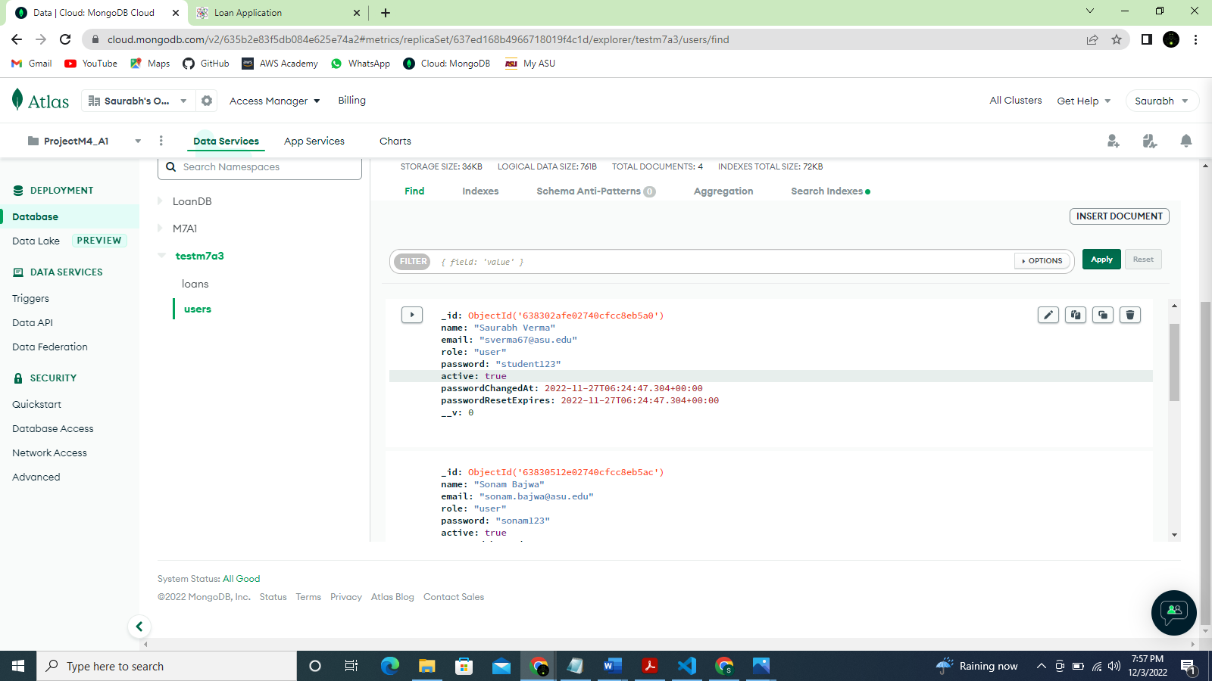

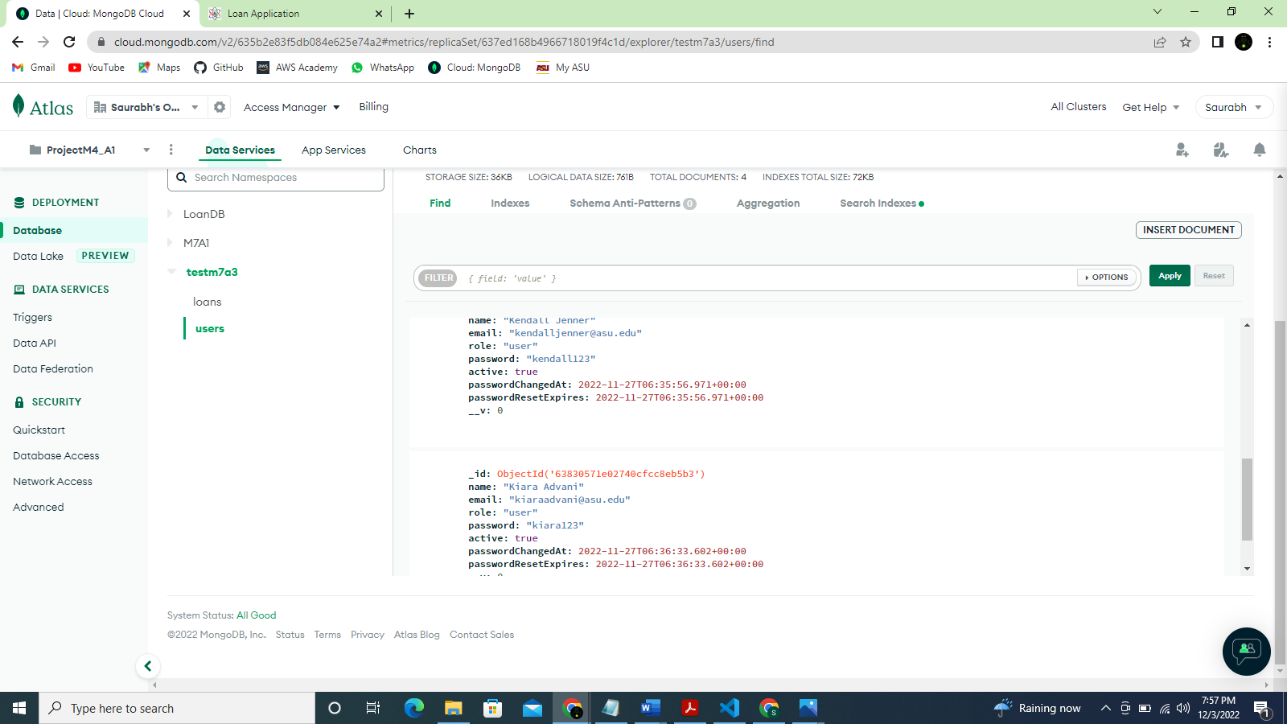

**Project output showing end to end application flow**

Overview page:

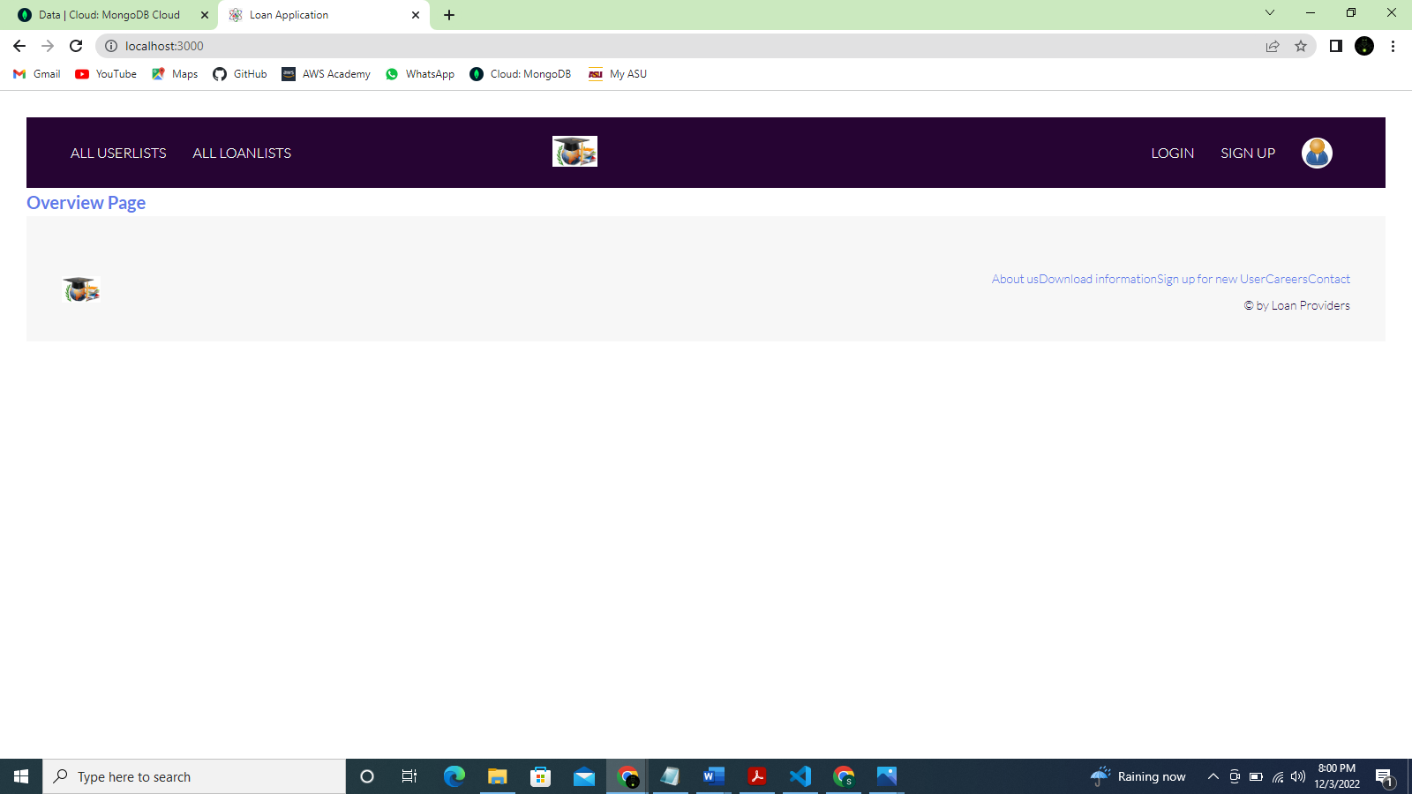

Signing up a new user:

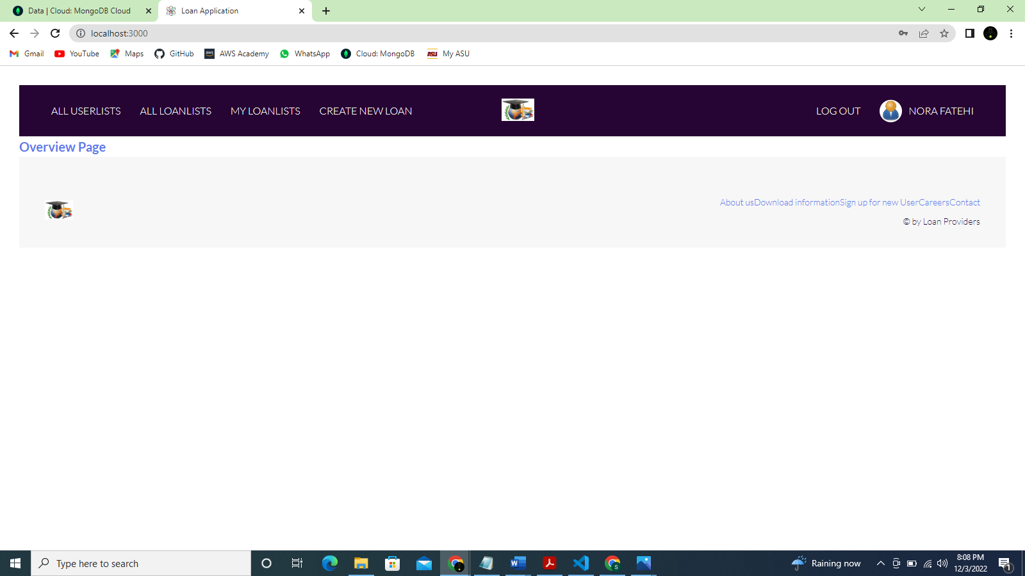

MongoDB screenshot of new user:

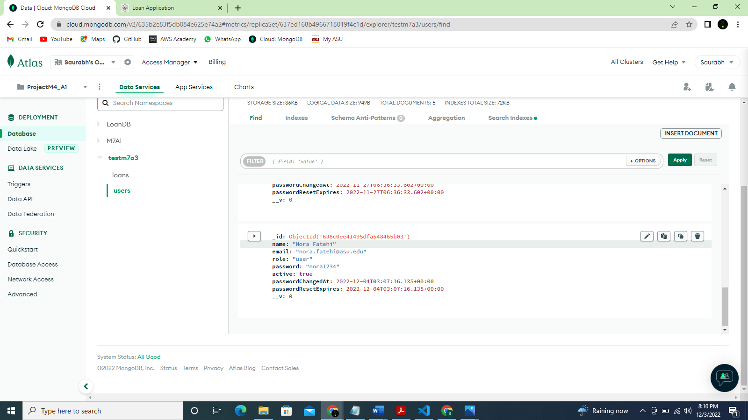

Create a new loan:

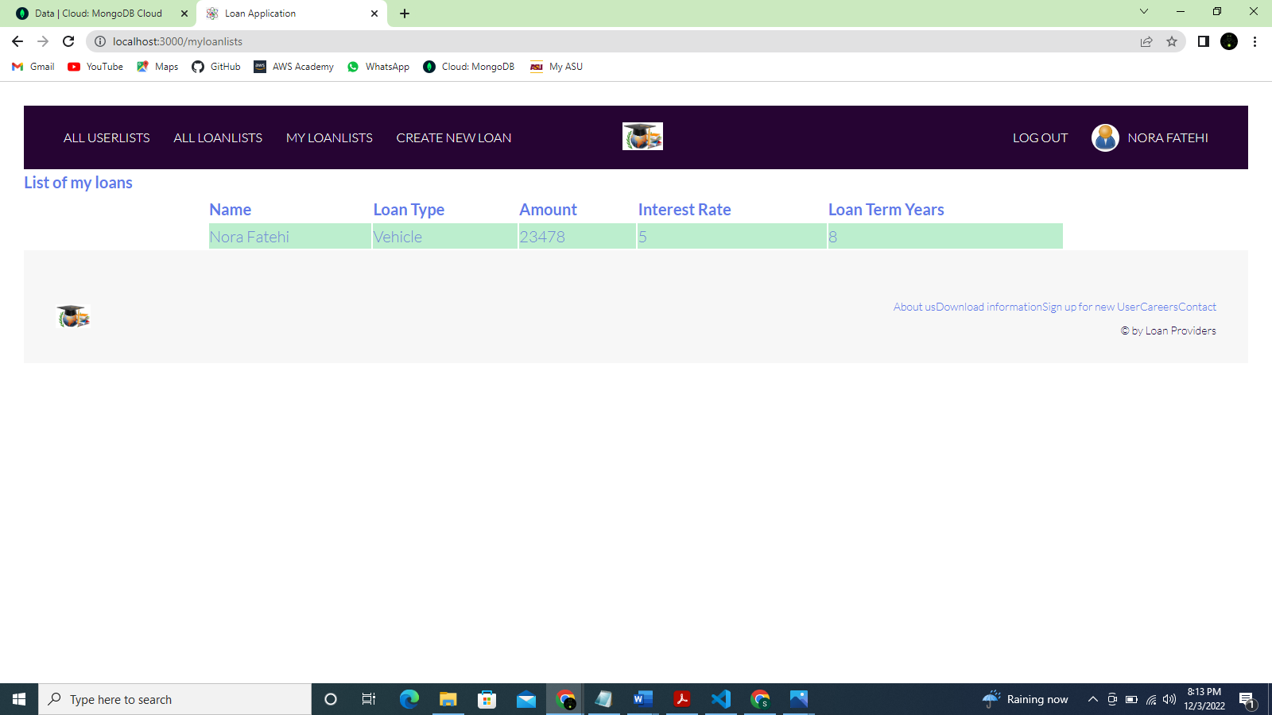

MongoDB screenshot of new loan:

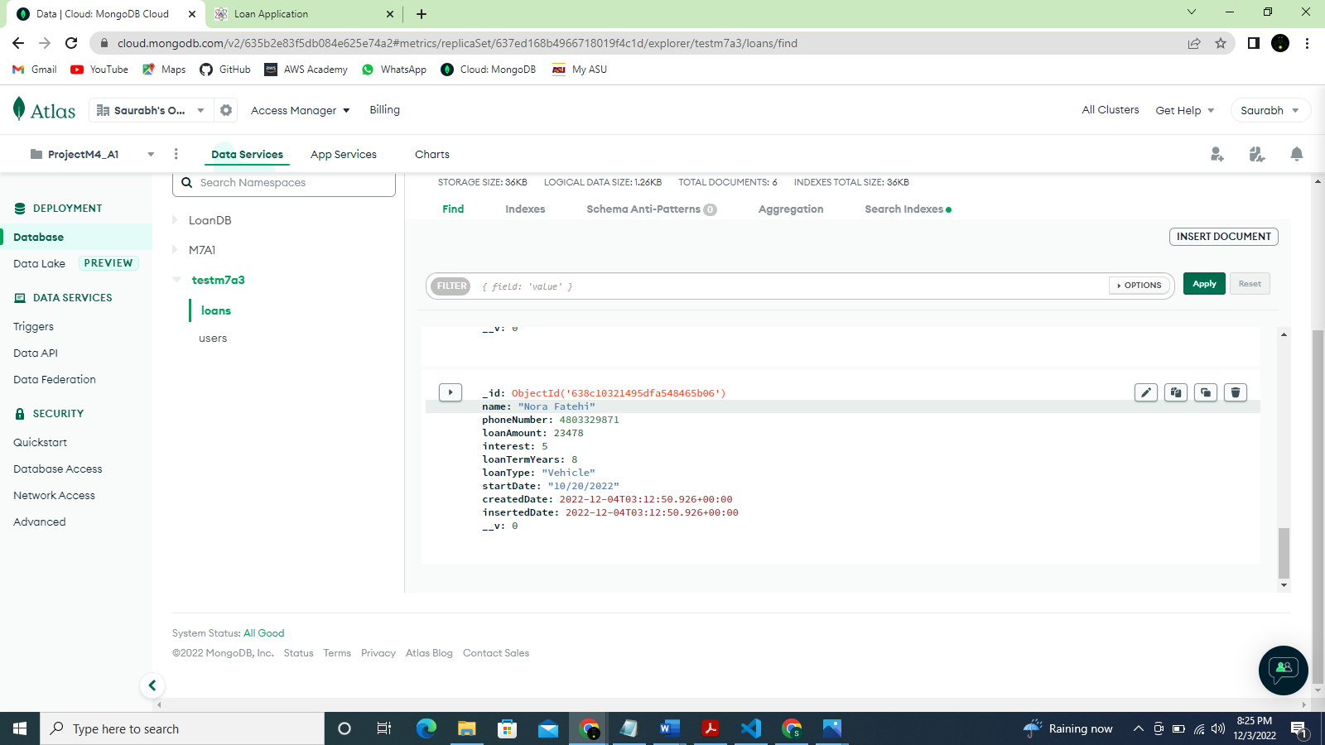

Loan list:

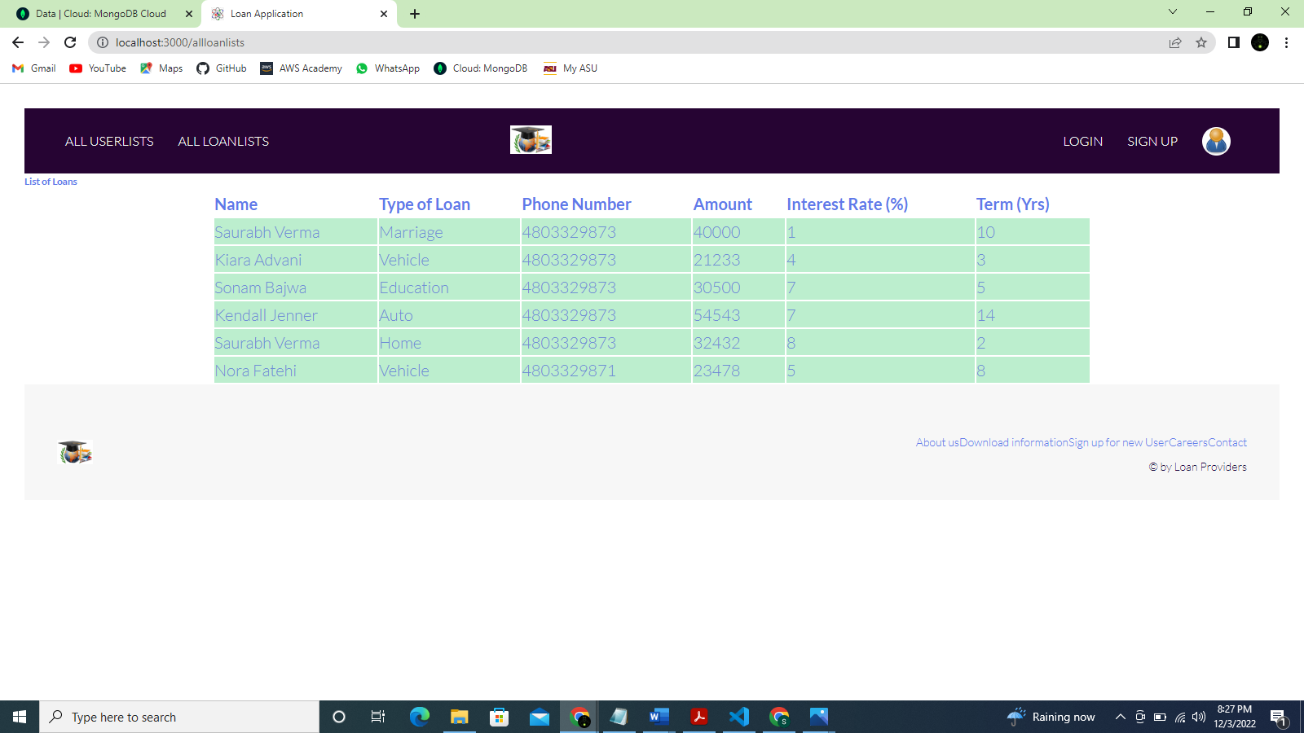

**POSTMAN testing:**

POSTMAN sign up:

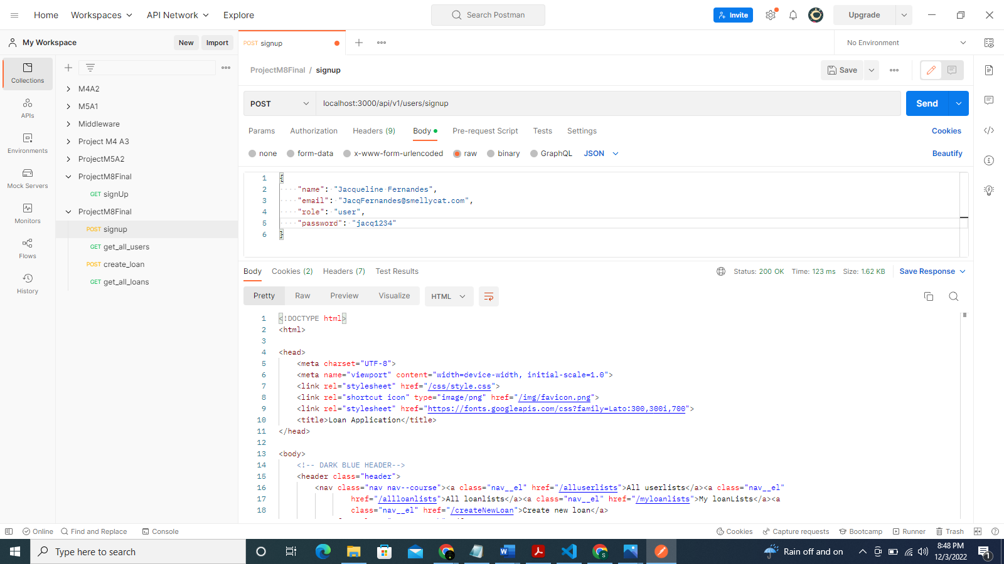

Loan list for new user:

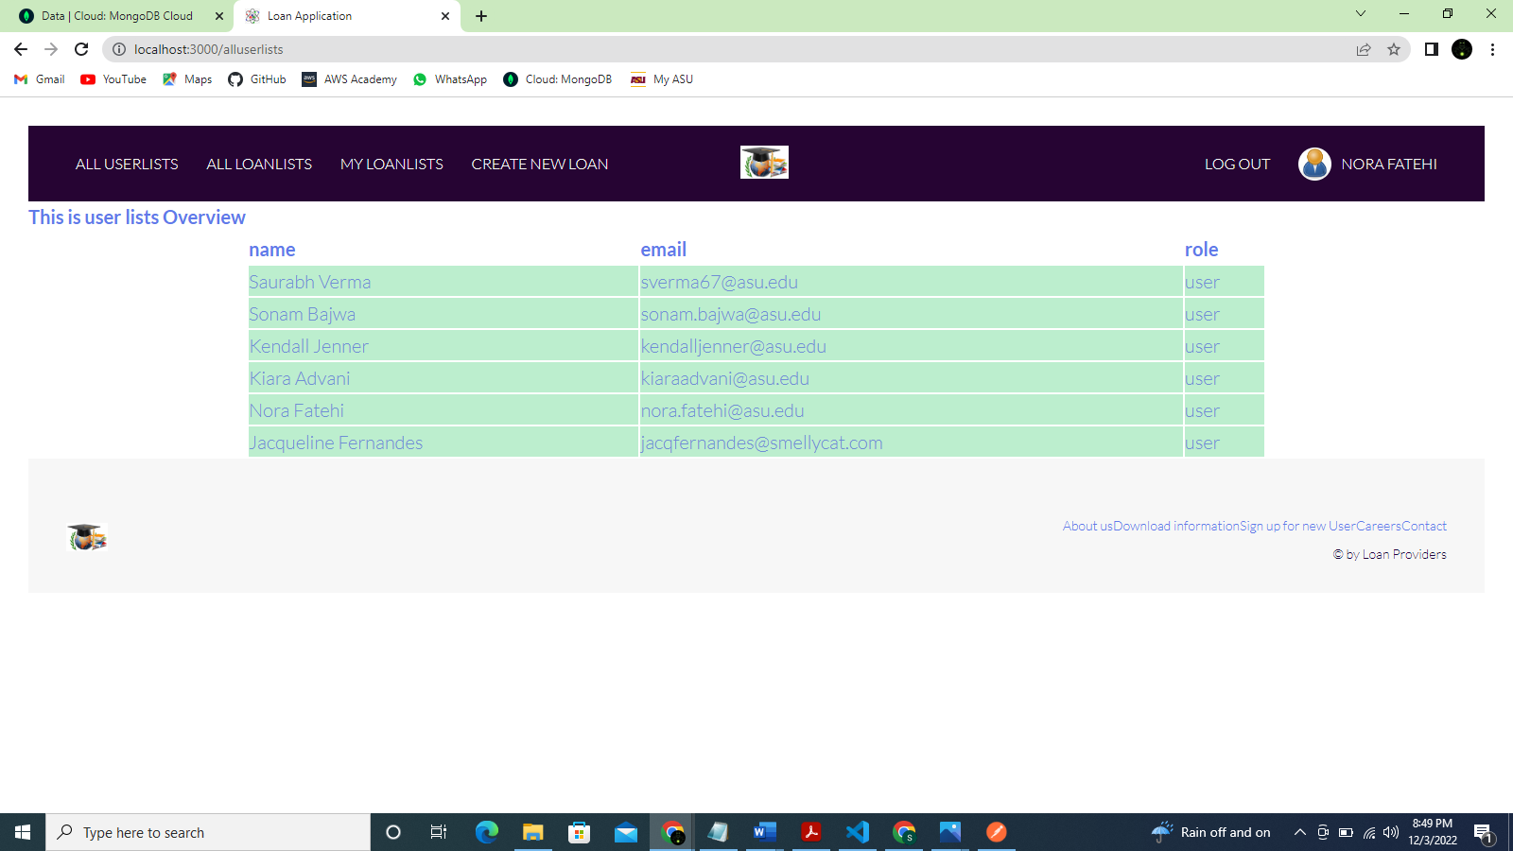

MongoDB record for new user:

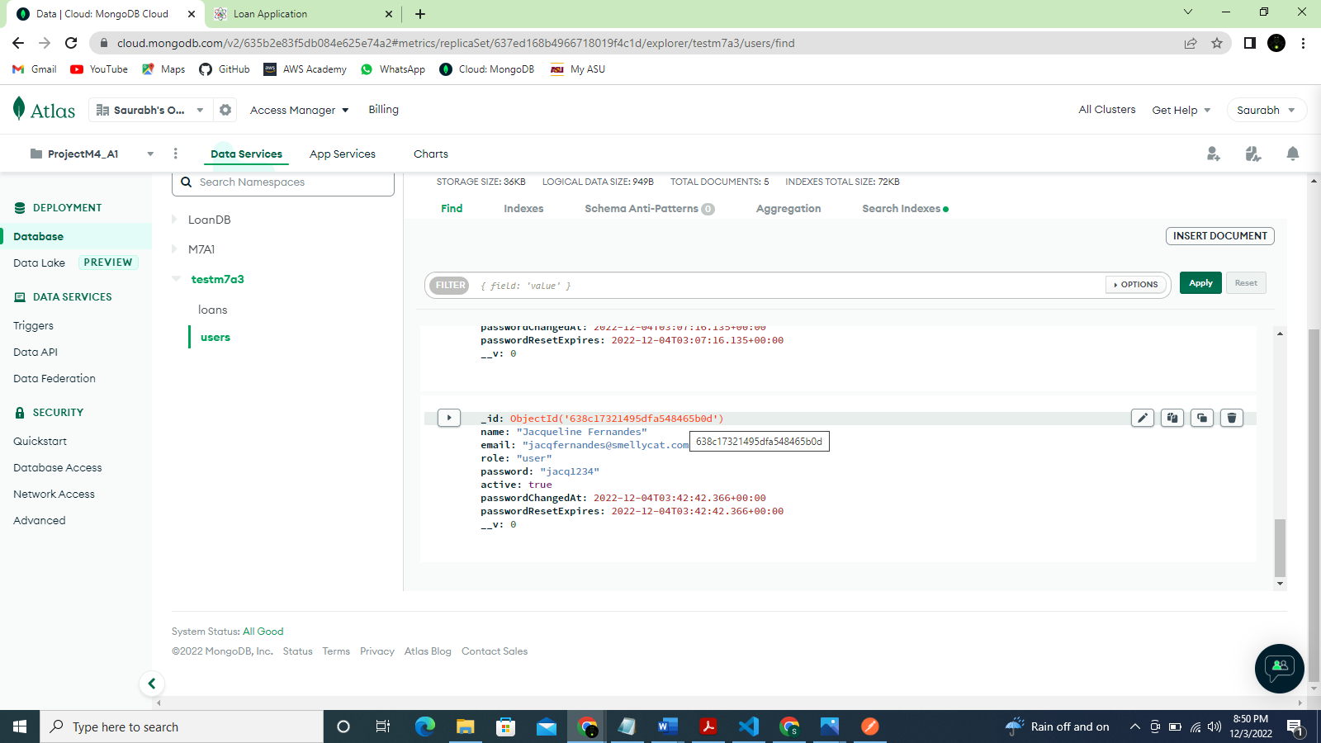

User list from POSTMAN:

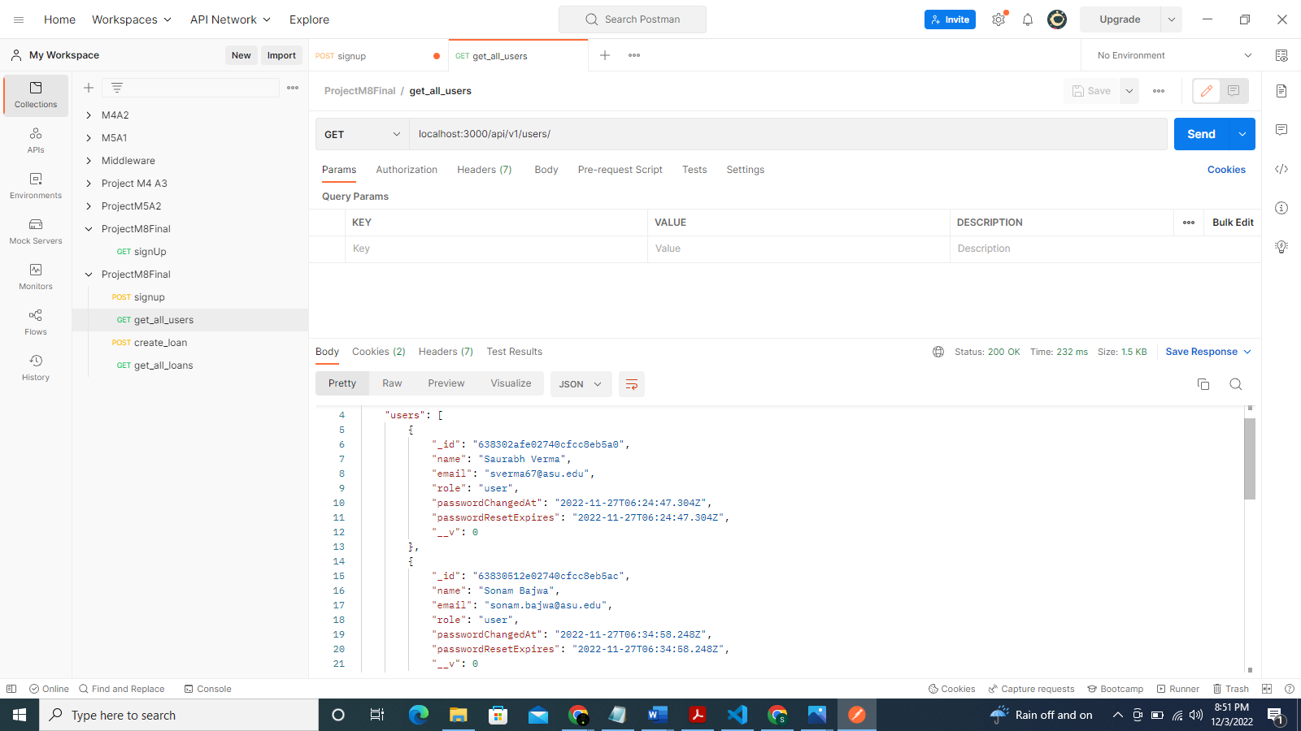

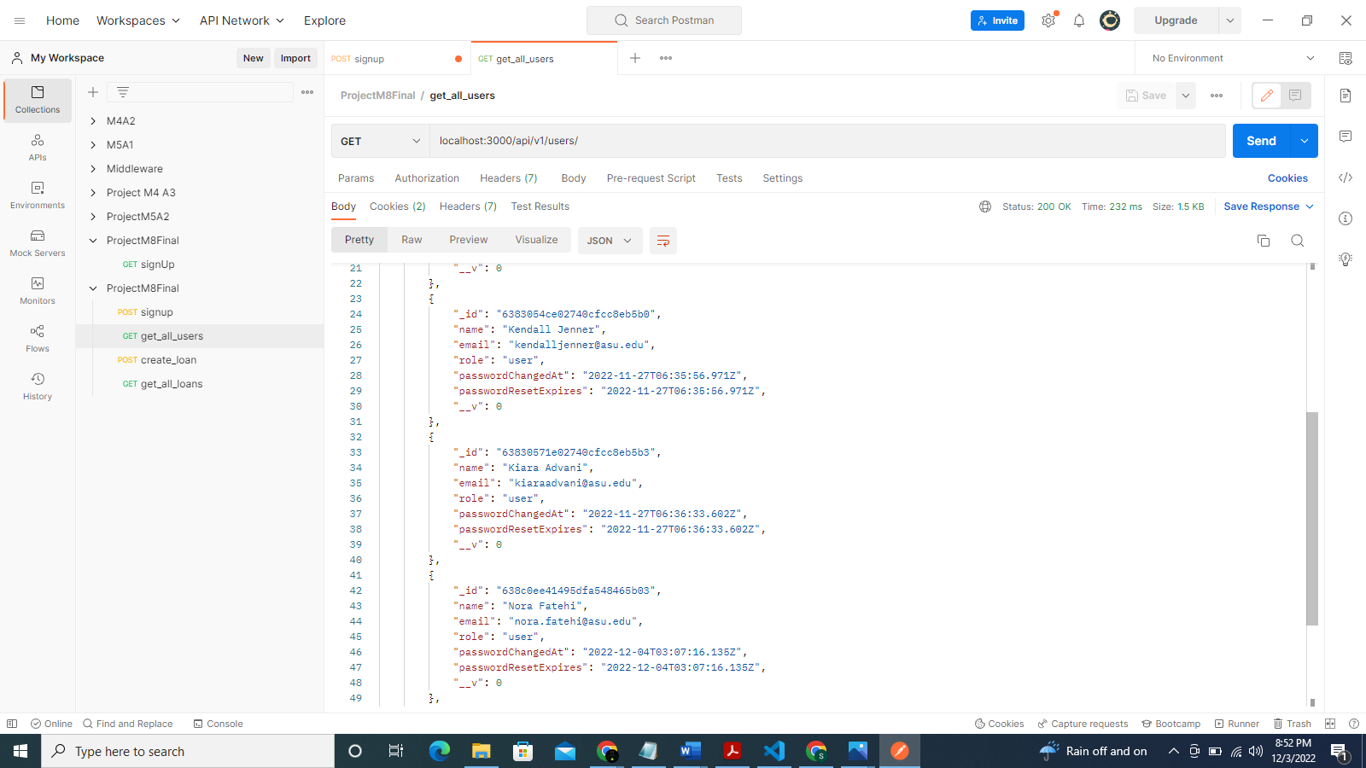

New loan for an existing user:

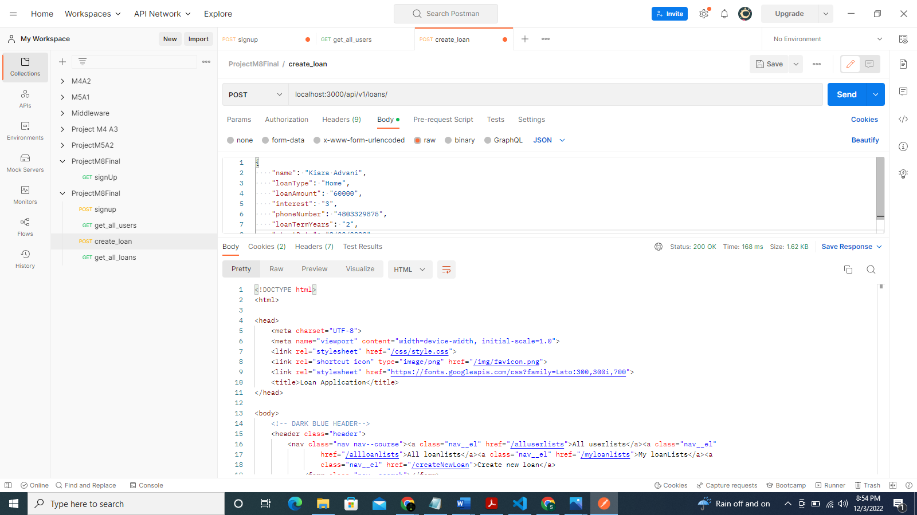

MongoDB screenshot for new loan:

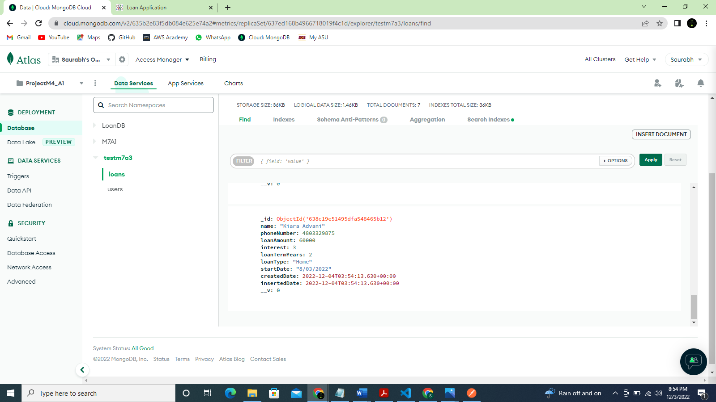

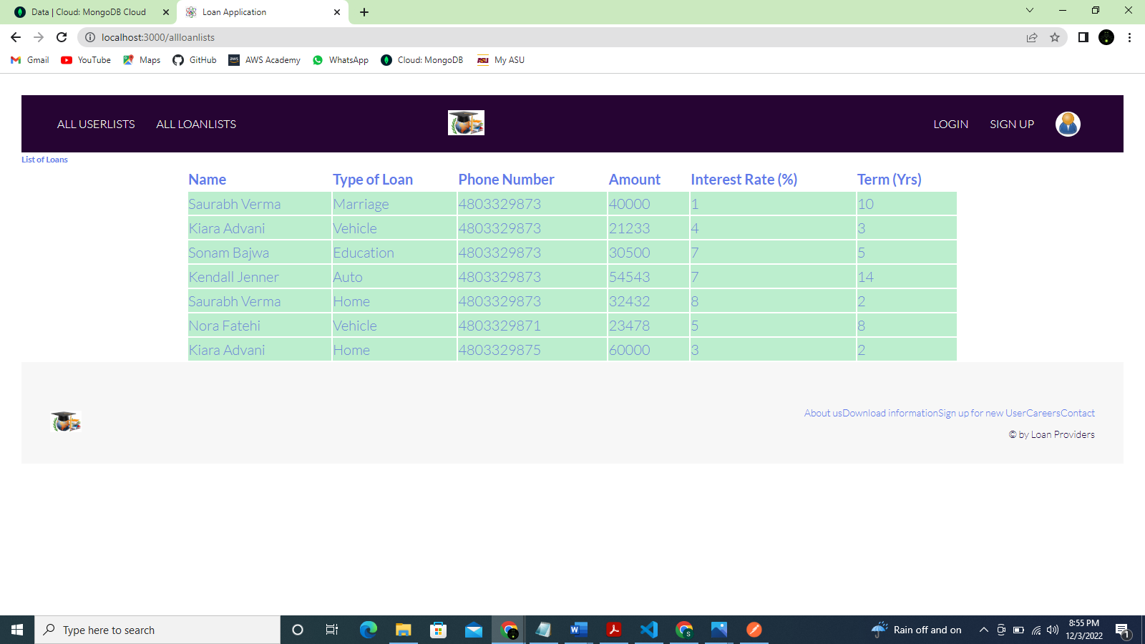

POSTMAN GET for all loans:

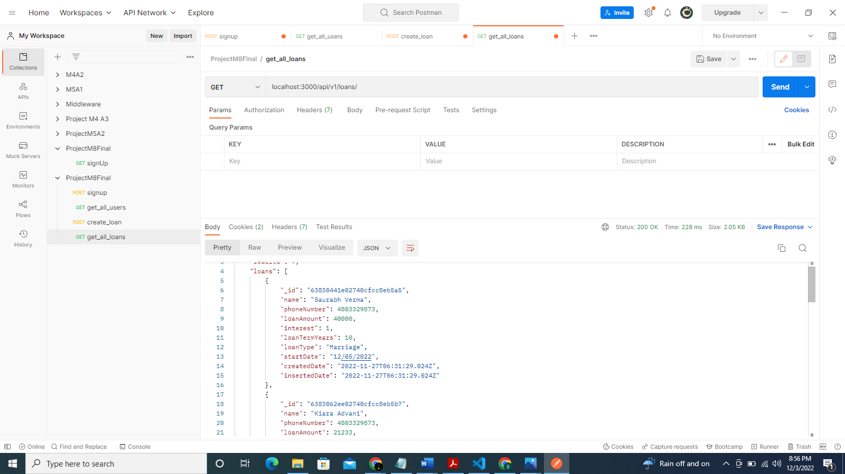

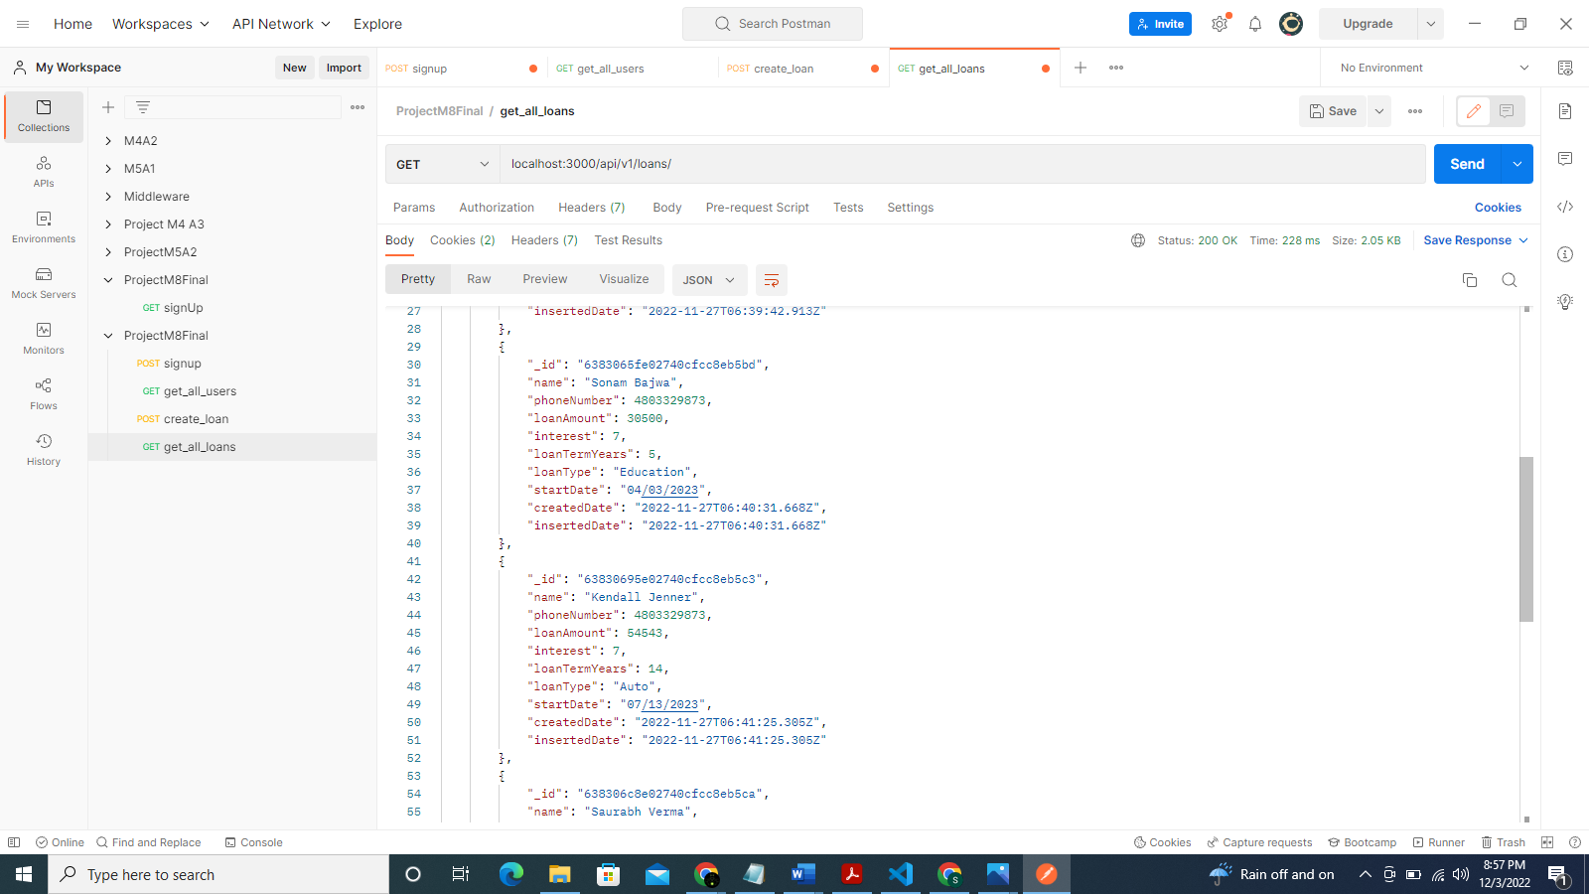

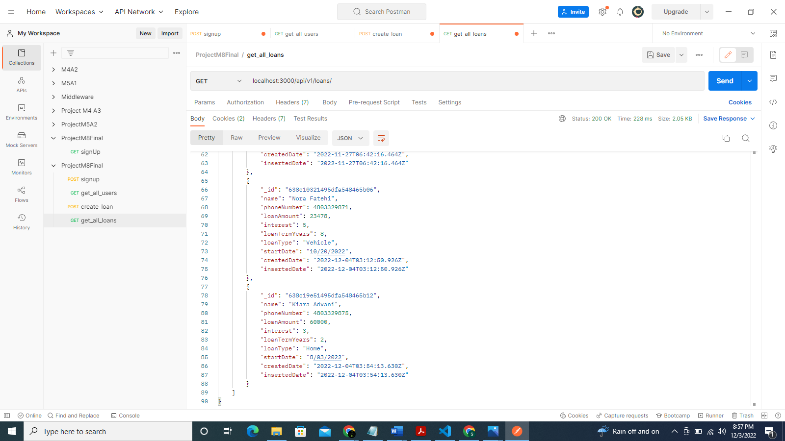

**Project Design**

A full stack web application connected to a MongoDB database makes up this project. An overview page with sign-up and sign-in features makes up the front-end user interface. Users of the program can also generate new loans for themselves, indicating that they have submitted fresh loan applications to the bank. They can access their loans to keep track of the loans they have taken and to check their loan information. All the loans are also visible to users who are not logged in.

The main file that launches the application and establishes a connection to the database makes up the project (server.js). Starting routes in the app.js direct the backend to the frontend. The middleware is made up of routes and controllers that manage how each page that the application redirects to is implemented. There is a file called viewRoutes.js in the routes that renders HTML for the client and directs the client to the middleware application. If the options the client selects on the page are user-related options, such as sign up for a user, it will take the client to the userRoute.js routes. It will be forwarded to loanRoutes.js if it is loan related. When logging in, creating a new user, or logging out of a user, the userRoutes.js redirects the route implementation to authController.js, which handles authentication to the user.

For each HTML route, the UI frontend is coded using PUG files, and the CSS for each page is modularized into a single CSS folder. The pictures folder houses all the frontend's images, which the PUG files can access as needed.

The Loans DB database, which includes users and loan collections, is part of the MongoDB database. The user collection contains of user data such the user's name, email address, password, and roles. The loan collection consists of user loan data organized by name. Loan type, loan amount, loan interest, and other information are included in the loan collection.

Risks of the project:

* The project can employ a more complex strategy to strengthen the authentication process when the user is logged in, or any application-related modification may have an adverse effect on the database. OAuth 2.0 and mTLS can be used for security.
* To reinstate the login period after the user logs in, better session management needs to be established.

Out of scope functionality:

* Authorizing the users and offering them additional activities based on their roles are both within the project's purview. The administrator, for instance, has access to the entire loan list.
* The project can be improved by adding a notification to the user about the loan due date so they can start making the loan payment.

**Project estimate**

The requirements acquired from the business can be used to construct the project estimate for this project. Assuming the developers are familiar with the technology they have chosen, this project could take up to 8 weeks to complete. It is possible to divide the eight weeks into four separate tasks: design finalization, full stack implementation, adding authentication and security, and finishing all testing.

**Learning experiences during this course:**

The first module, Module 1, taught me about JavaScript and how the backend and frontend are connected. I acquired the knowledge necessary to produce JSON data on the front end. I was able to learn how the server operates and how the front end connects to the back end thanks to this.

I learned more about JavaScript's data types and syntax thanks to Module 2. I wrote a JavaScript function.

I learned about several JavaScript data types, external modules, and content negotiation in module 3. I also discovered how to use JavaScript to connect to a SQL server. I acquired the ability to draw complex ER diagrams.

I was able to better comprehend MongoDB on the cloud thanks to Module 4. I adhered to the professor's recommendations, which enabled me to learn more about the MongoDB database framework. I gained knowledge about effective database design, cloud MongoDB setup, and MongoDB Atlas NoSQL database creation.

I evaluated the Java Web token authentication flow using Module 5 to better understand how to test the code using POSTMAN. While utilizing the JWT token to encrypt the password before saving it in the database, I realized the value of security.

I learned how to create PUG files in Module 7 and how to more effectively modularize HTML code. Rather than being in-line documents, the PUG file should be designed in modules. I developed a sign-up and sign-in page in PUG and thoroughly tested it.

I was able to compile all of my knowledge and all of the module's codes in Module 8 and create a complete web application for users in the banking industry.

**References**

GitHub link: [End-to-end-Application](https://github.com/SaurabhVerma200/End-to-end-Application)